United Federal Credit Union – Press Release
September 17, 2021

Contact: Diana Wake
Phone: (888) 982-1400 ext. 6891
Email: dwake@UnitedFCU.com
United Federal Credit Union, 150 Hilltop Road, St. Joseph, Michigan, 49085

United Federal Credit Union Names Julian Hernandez
Mortgage Advisor at Promenade Branch in Rogers, Arkansas
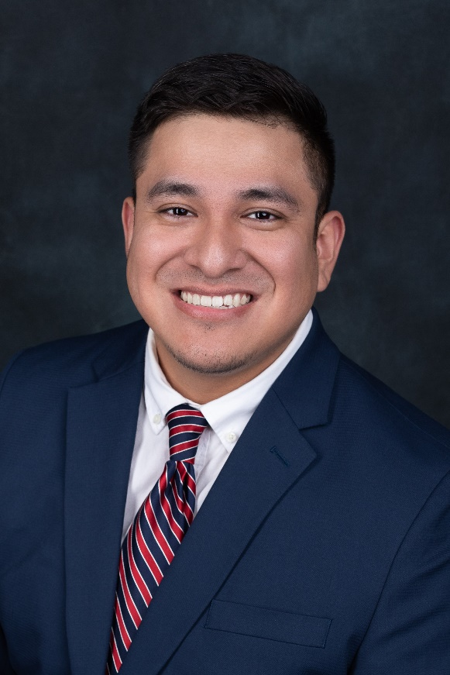
Julian Hernandez, Mortgage Advisor, Promenade Branch

ROGERS, Ark. – United Federal Credit Union (United) is pleased to announce the appointment of Julian Hernandez as Mortgage Advisor at its branch at 2000 S. Promenade Boulevard, Suite 103, in Rogers, Arkansas.

Hernandez will provide quality real estate lending expertise through financial counseling and product awareness to credit union members regarding their real estate financing needs and generate investment quality mortgage loans. He is bilingual in English and Spanish and is ready to assist families in the Rogers area.

Hernandez brings more than eight years of mortgage and financial experience to his new role. Most recently, he was a Mortgage Broker with Motto Mortgage. He pairs his industry knowledge with a passion to help people find the right mortgage option for their new home.

Hernandez has an associate’s degree in business management and administration from Northwest Arkansas Community College. He lives the credit union philosophy of ‘people helping people’ not only through member service, but also community involvement and is looking forward to working with United’s community partners in the Rogers area.
____________
About United
United Federal Credit Union has served its Members since 1949 by helping them to build a sound financial future. United consists of more than 180,000 Member/owners worldwide and manages assets in excess of $3.7 billion. Its corporate offices and main branch are in St. Joseph, Mich., with additional branches in Arkansas, Indiana, Michigan, Nevada, North Carolina, and Ohio. Federally insured by NCUA. Equal opportunity lender. Equal housing lender. For more information visit UnitedFCU.com

# # #

