

**United Federal Credit Union – Press Release**

November 15, 2021

Contact: Diana Wake

Phone: (888) 982-1400 ext. 6891

Email: [dwake@UnitedFCU.com](mailto:dwake@UnitedFCU.com)

United Federal Credit Union, 150 Hilltop Road, St. Joseph, Michigan, 49085

**United Federal Credit Union Names New Regional Market Development Manager and Branch Manager in Northwest Arkansas**

**SPRINGDALE, Ark. –** United Federal Credit Union (United) has named a new Regional Market Development Manager and Branch Manager in Rogers and Springdale, Arkansas.

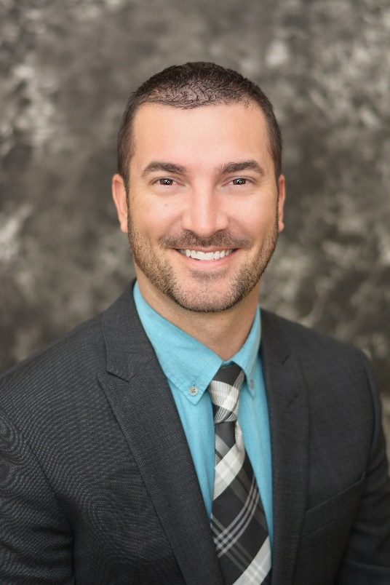

*Kyle Hathaway, Regional Market Development Manager*

Kyle Hathaway has been promoted to Regional Market Development Manager. Hathaway is based at the branch at 2000 S. Promenade Blvd, Suite 103 in Rogers.

As Regional Market Development Manager, Hathaway will be responsible for results-driven business development while promoting corporate member engagement, business and consumer membership and loan growth, and positive public relations. As part of this objective, Hathaway will identify and recruit new members in new and existing markets as well as develop and maintain existing corporate memberships.

Hathaway has more than ten years of financial industry experience in the northwest Arkansas area. He has held multiple roles with United. Most recently, Hathaway spent three years as the branch manager at the Har-Ber Meadows location.

Hathaway lives the credit union philosophy of ‘people helping people’ not only through member service, but also community involvement.

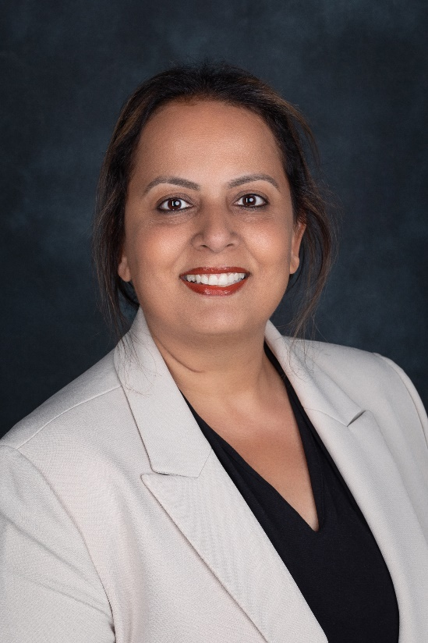

*Zina Marshall, Branch Manager*

United has named Zina Marshall to the position of Branch Manager at its Har-Ber Meadows branch at 6706 W. Sunset Ave. in Springdale.

As Branch Manager, Marshall will be responsible for maintaining the performance of the branch, and providing leadership and supervision to staff. Marshall brings more than seven years of financial industry experience to her new role. Most recently, she spent more than two years as a Member Service Advisor with United.

She has a degree from Baghdad University. Marshall is looking forward to supporting United’s community efforts in the Springdale area.

**____________**

**About United**

United Federal Credit Union has served its Members since 1949 by helping them to build a sound financial future. United consists of more than 180,000 Member/owners worldwide and manages assets in excess of $3.7 billion. Its corporate offices and main branch are in St. Joseph, Mich., with additional branches in Arkansas, Indiana, Michigan, Nevada, North Carolina, and Ohio. Federally insured by NCUA. Equal opportunity lender. Equal housing lender. For more information visit [UnitedFCU.com](http://www.unitedfcu.com)

# # #