United Federal Credit Union – Press Release
August 17, 2021

Contact: Diana Wake
Phone: (888) 982-1400 ext. 6891
Email: dwake@unitedfcu.com
United Federal Credit Union, 150 Hilltop Road, St. Joseph, Michigan, 49085

United Federal Credit Union Names Susana Alcala
Mortgage Advisor in Reno, Nevada
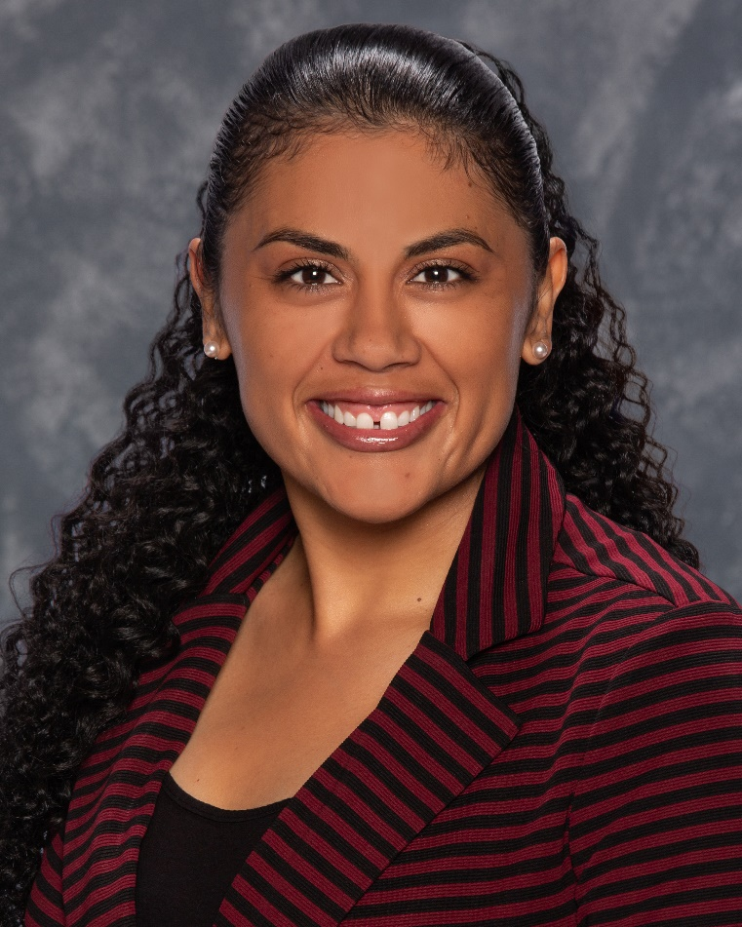
Susana Alcala, Mortgage Advisor, Bible Way Branch

RENO, Nev. – United Federal Credit Union (United) is pleased to announce the appointment of Susana Alcala as Mortgage Advisor at its branch at 1170 Bible Way in Reno.

Alcala will provide quality real estate lending expertise through financial counseling and product awareness to credit union members regarding their real estate financing needs and generate investment quality mortgage loans. She is bilingual in English and Spanish and ready to assist families in the Northern Nevada region.

Alcala brings more than 14 years of mortgage and financial experience to her new role. Most recently, she was a Mortgage Loan Officer for Greater Nevada Mortgage. She pairs her industry knowledge with a passion to help people find the right mortgage option for their new home.

Alcala lives the credit union philosophy of ‘people helping people’ not only through member service, but also community involvement. She is looking forward to working with United’s community partners in northwest Nevada including United Way of Northern Nevada and the Sierra and the Boys and Girls Club of Truckee Meadows.

____________
About United
United Federal Credit Union has served its Members since 1949 by helping them to build a sound financial future. United consists of more than 180,000 Member/owners worldwide and manages assets in excess of $3.7 billion. Its corporate offices and main branch are in St. Joseph, Mich., with additional branches in Arkansas, Indiana, Michigan, Nevada, North Carolina, and Ohio. Federally insured by NCUA. Equal opportunity lender. Equal housing lender. For more information visit www.unitedfcu.com

# # #

