United Federal Credit Union – Press Release
August 24, 2021

Contact: Diana Wake
Phone: (888) 982-1400 ext. 6891
Email: dwake@UnitedFCU.com
United Federal Credit Union, 150 Hilltop Road, St. Joseph, Michigan, 49085

United Federal Credit Union Names Tina Vaught
Branch Manager at State Street Branch in St. Joseph
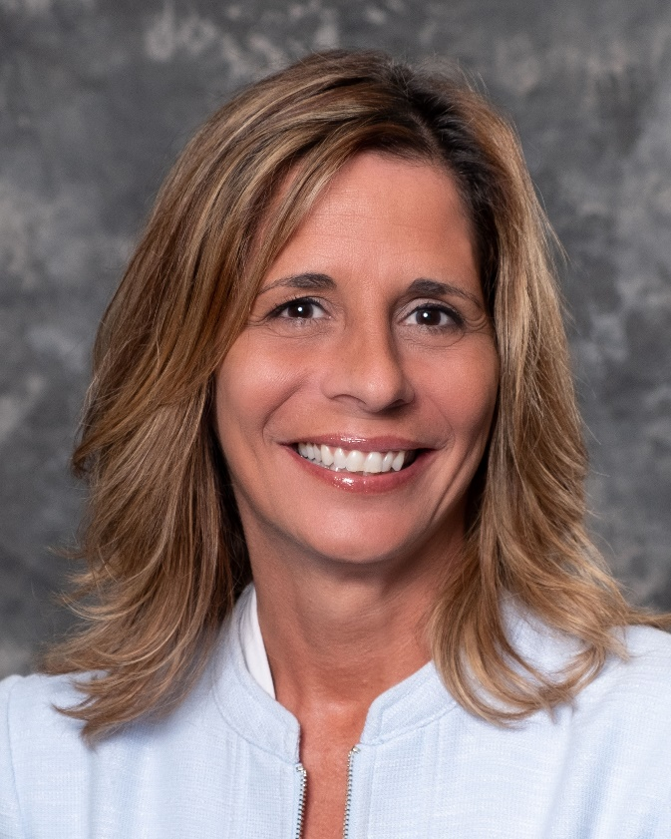
Tina Vaught, Branch Manager, State Street Branch

ST. JOSEPH, Mich. – United Federal Credit Union (United) has named Tina Vaught to the position of Branch Manager at its State Street branch in St. Joseph, Michigan.

As Branch Manager, Vaught will be responsible for maintaining the performance of the branch, and providing leadership and supervision to staff.

Vaught brings more than 15 years of financial and customer service experience to her new role. Most recently, she was the Financial Center Manager for Fifth Third Bank for locations in Coloma and Watervliet. She holds a bachelor of science degree in financial management from the University of Phoenix.

Vaught lives the credit union philosophy of ‘people helping people’ not only through member service, but also community involvement. She is looking forward to being part of United’s community impact efforts by supporting organizations such as the United Way of Southwest Michigan, the Boys & Girls Club of Benton Harbor and other local non-profit groups.

____________
About United
United Federal Credit Union has served its Members since 1949 by helping them to build a sound financial future. United consists of more than 180,000 Member/owners worldwide and manages assets in excess of $3.7 billion. Its corporate offices and main branch are in St. Joseph, Mich., with additional branches in Arkansas, Indiana, Michigan, Nevada, North Carolina, and Ohio. Federally insured by NCUA. Equal opportunity lender. Equal housing lender. For more information visit UnitedFCU.com

# # #

