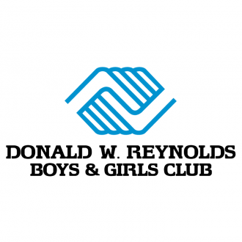

Press Release
January 26, 2021

Contact: Matt Orlando
Phone: (888) 982-1400 ext. 1473
Email: morlando@unitedfcu.com
United Federal Credit Union, 150 Hilltop Road, St. Joseph, MI 49085

United Federal Credit Union Sponsors Programs
for Donald W. Reynolds Boys & Girls Club

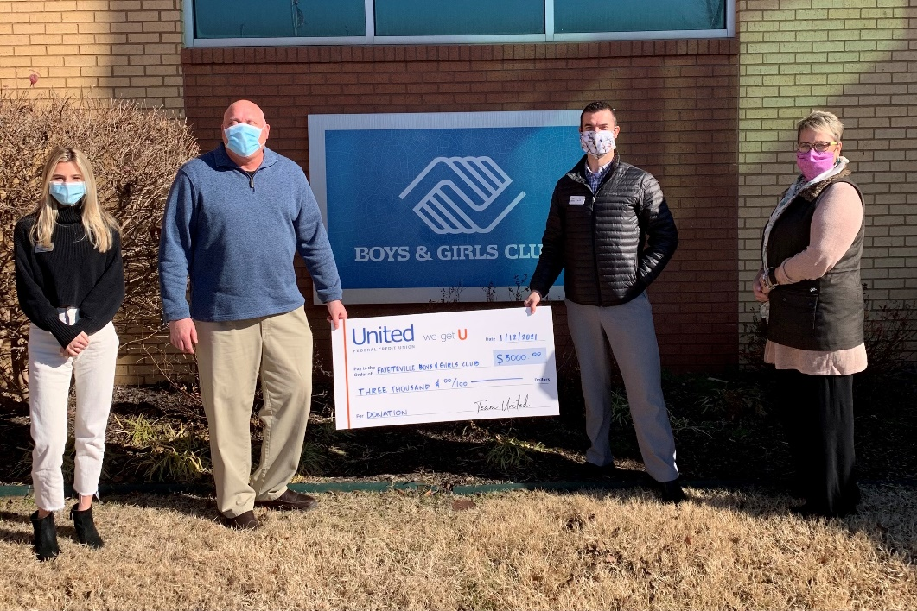
L to R: Clare Green, Development and Marketing Specialist—Boys & Girls Club, Eric Schuldt, Chief Professional Officer—Boys & Girls Club, Kyle Hathaway, Branch Manager Har-Ber Meadows—United Federal Credit Union, Stacy Warren, Regional Market Development Manager—United Federal Credit Union.

FAYETTEVILLE, Ark. – United Federal Credit Union (United) is excited to announce it is partnering with the Donald W. Reynolds Boys & Girls Club to support a variety of programs for families, senior citizens, and children.

“United Federal Credit Union has stepped up in a big way for our Club members and our community,” says Clare Green, Resource Development Manager of the Donald W. Reynolds Boys & Girls Club. “It’s important for us to keep active and socially engaged, even when physical distancing measures are in place. We are extremely thankful for this donation and the support of United.”

United’s partnership with the Donald W. Reynolds Boys & Girls Club includes a $4,000 donation that will fund programs such as one open swim night for the community per month at the Club from June thru September, the ZING summer program for children, and the Club’s annual Thanksgiving event.

“We know how important it is to continue supporting non-profit organizations like the Donald W. Reynolds Boys & Girls Club Boys and Girls Club—especially during challenging times,” said Stacy Warren, United’s Regional Market Development Manager. “The team at United is happy to do our part to provide the Club and the community with opportunities to enjoy some fun and fellowship.”

United has also recently partnered with the Boys & Girls Club of Benton County and the Boys & Girls Club of Fort Smith to help fund programs and transportation needs.
____________

About United
United Federal Credit Union has served its Members since 1949 by helping them to build a sound financial future. United consists of more than 177,000 Member/owners worldwide and manages assets in excess of $3.2 billion. Its corporate offices and main branch are in St. Joseph, Mich., with additional branches in Arkansas, Indiana, Michigan, Nevada, North Carolina, and Ohio. Federally insured by NCUA. Equal opportunity lender. Equal housing lender. For more information visit www.unitedfcu.com

____________
About the Donald W. Reynolds Boys & Girls Club
The Donald W. Reynolds Boys & Girls Club is a non-profit 501 (C)(3) organization currently serving over 10,000 community members per year through memberships, special events, facility reservations and drop-in business. Formerly known as the Fayetteville Youth Center, the Club has over 75 years of service to youth and families in the local community. For more information visit https://www.fayettevillekids.org/

