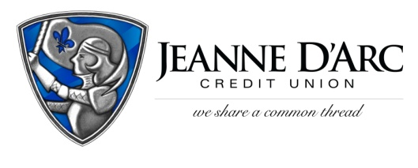

FOR IMMEDIATE RELEASE CONTACT: Robin Lorenzen
978-323-3226
February 17, 2022

Jeanne D’Arc Credit Union to hold In-person
We Share A Common Thread Foundation Fundraiser

LOWELL, MA – Jeanne D’Arc Credit Union is excited to announce the twelfth annual We Share A Common Thread Foundation Fundraiser to be held on Wednesday, March 30, 2022, from 6:00 pm to 10:00 pm at the Lowell Memorial Auditorium.
The We Share a Common Thread Foundation was established in 2011 to provide monetary support to numerous charities and organizations throughout the Greater Lowell area that support the Foundation’s mission of food, shelter, clothing, healthcare, and education.
This year’s event will once again bring together in-person Jeanne D’Arc Credit Union employees, business partners, members, and community supporters to gather for a night filled with live music by Martin and Kelly, food samples from Grazie Italian Restaurant in Dracut, MA, Owen & Ollie's Restaurant & Pub in Dracut, MA, and the Greater Lowell Technical High School Culinary Arts program. There will also be games, raffle baskets, a silent auction, gift card pull, and much more.
Funds raised during this fun-filled night will be distributed to hundreds of worthy non-profit organizations within Greater Lowell and surrounding communities.
Due to COVID-19, the 2020 Fundraiser was held virtually and the 2021 event was held in a hybrid format raising $95,000 with funds allocated to 132 non-profits in the area.
The Credit Union is honored to once again have Fiserv, Inc., a global provider of financial service technology, as its Common Thread Sponsor, the highest level of sponsorship.
The Foundation is seeking donations and sponsorships. More information can be found at www.WSACT.com. Tickets to the event can also be purchased at www.WSACT.com for $25 each or $250 for a table of 10.
For additional information regarding sponsorships, donations, or to purchase a table contact Alison Hughes at Alison.Hughes@JDCU.com or at 978-323-4712.

###
About Jeanne D’Arc Credit Union:
Jeanne D’Arc Credit Union was established in 1912 and is a full-service, community-based financial cooperative. Locally owned by 93,000 members with $1.7 billion in assets, Jeanne D’Arc operates eight full-service branches in Lowell, Dracut (2), Tyngsboro, Chelmsford, Methuen and Westford, Massachusetts and Nashua, New Hampshire; high-school branches at Lowell High, Dracut High, and Nashua High School South; a loan center in Lowell; and a mortgage center in Chelmsford.

