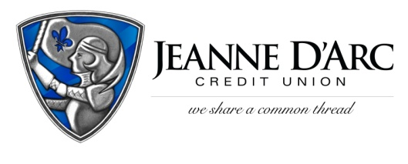

FOR IMMEDIATE RELEASE CONTACT: Robin Lorenzen
WITH PHOTO 978-323-3226

September 7, 2021

Jeanne D’Arc Credit Union Celebrates International Day of Charity Winner
LOWELL, MA – Jeanne D’Arc Credit Union is pleased to present the winners of the first International Day of Charity campaign to Meals on Wheels of Hillsborough County and volunteer, Arlene Hutchinson. A $250 donation in Arlene’s name has been made to Meals on Wheels, and Arlene also received $250.
International Day of Charity commemorates the anniversary of the passing of Mother Teresa. This day reminds us that small acts of charity can make a big difference in someone’s life. To celebrate, Jeanne D’Arc Credit Union wanted to recognize a special volunteer. Local nonprofits nominated one volunteer from their organization to be recognized. This year, the winner is Meals on Wheels of Hillsborough County’s volunteer, Arlene Hutchinson.
Since her tenure began in 2018, Arlene Hutchinson has given almost 400 hours of volunteer service, delivered countless meals, and put a smile on the face of every senior. When Arlene first learned about Meals on Wheels, she recognized the impact that it had on her community, and she wanted to be a part of it, “I discovered early on that I really like helping seniors, and even in the short period of time we are with them, it means so much,” said Arlene. She also acknowledged that family connections and stories are part of the volunteer job. “When you do this work, you get to know the people, their families, and even their pets sometimes, and they look forward to seeing you. It’s a wonderful feeling to see someone smile, and to know that you are helping them.”
We are always looking for ways to highlight community members who give selflessly to those around them,” said Mark S. Cochran, President and Chief Executive Officer. “We applaud Arlene and the difference she is making in the lives of so many.”
Meals on Wheels of Hillsborough County has been servicing the community for over 40 years. They deliver meals to individuals in the community who are not able to purchase or prepare their own. They depend on more than 200 volunteers annually to help serve and transport meals. Volunteers deliver more than meals, they also do wellness checks and provide comfort for their participants.
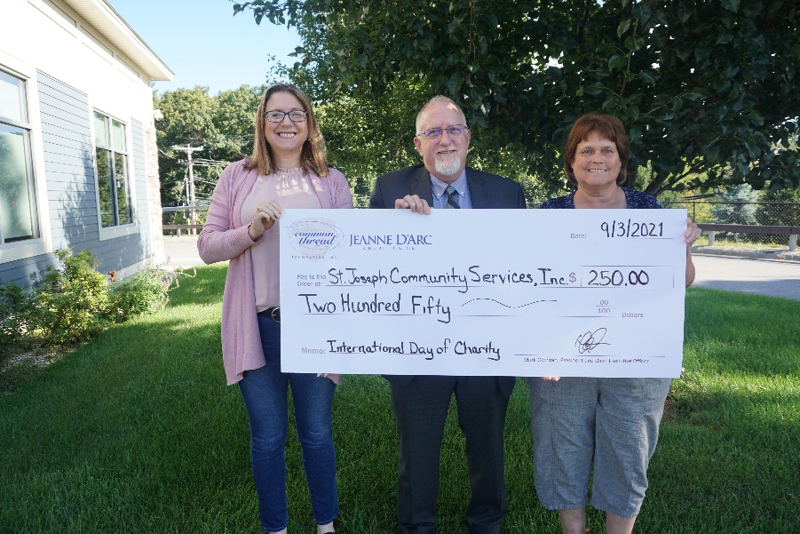
Arlene Hutchinson, right, volunteer driver for Meals on Wheels of Hillsborough County, & Jon Eriquezzo, center, President of Meals on Wheels of Hillsborough County accepting a check from Alison Hughes, AVP – Community Engagement Officer, as the winner of Jeanne D’Arc Credit Union’s International Day of Charity Campaign.

###

About Jeanne D’Arc Credit Union:
Jeanne D’Arc Credit Union was established in 1912 and is a full-service, community-based financial cooperative. Locally owned by 93,000 members with $1.7 billion in assets, Jeanne D’Arc operates eight full-service branches in Lowell, Dracut (2), Tyngsboro, Chelmsford, Methuen and Westford, Massachusetts and Nashua, New Hampshire; high-school branches at Lowell High, Dracut High, and Nashua High School South; a loan center in Lowell; and a mortgage center in Chelmsford.

