News Release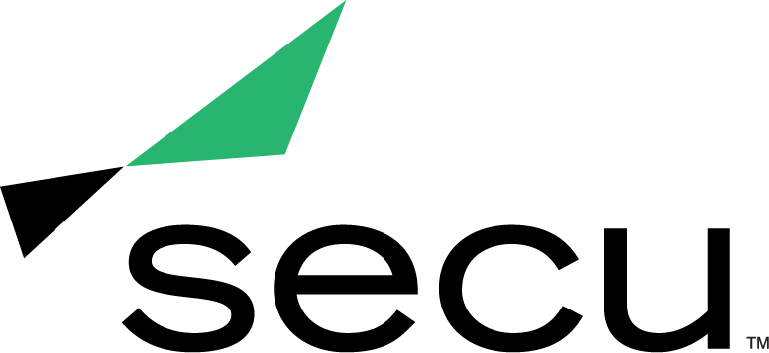

**Teshia Davis Honored with Ragan’s Top Women in Wellness and HR Awards**

*Awards honor leadership in human resources and workplace wellness*

**BALTIMORE** (December 6, 2021) — [SECU](http://www.secumd.org), Maryland’s largest state chartered credit union, announced today that Teshia Davis, Vice President of People & Culture, was recognized as an honoree in the “Trailblazer” and “Diversity, Equity & Inclusion Leader” categories of Ragan’s 2021 Top Women in Wellness and HR Awards.

As the leading information resource for internal communicators for more than 50 years, Ragan continues to chronicle the challenges and opportunities for those communicating with employees across an organization. Honorees on Ragan’s Top Women in Wellness and HR list are leading the charge in human resources and workplace wellness, ensuring that quality, employee well-being, productivity and morale are at their highest.

“At SECU, our employees are at the heart of everything we do. It’s been more important than ever to stay connected with our employees - both in-person and virtually - and proactively offer support for any professional or personal challenges they might be facing,” said Dave Sweiderk, President and CEO at SECU. “Through her forward-thinking and compassion, Teshia has ensured that our employees remain top-of-mind and that our workplace continues to foster growth and remains both diverse and inclusive.”

Over the past year, Davis brought SECU’s strategic vision to life through innovation, resulting in higher levels of employee engagement. Working with SECU’s executive leadership team, Davis’ efforts included modeling various employment scenarios to prevent furloughs through the pandemic, leading employee communication efforts, creating and collaborating on employee gift initiatives, and presenting on pandemic-related matters at SECU town hall events to put employees at ease while balancing transparency.

To further cultivate a sense of connection and belonging for employees, Davis led the development and implementation of a new rewards and recognition program, SPARK, that connected strongly to SECU’s core values. Davis also developed SECU’s mission and messaging for Diversity, Equity and Inclusion (DE&I), which included the creation of a comprehensive roadmap to help infuse DE&I practices in all SECU programs and efforts. She also collaborated with an external partner to facilitate all-employee roundtable discussions without bias, developed a micro-website on DE&I, and introduced employee resource groups at SECU based on a wide array of demographics.

To recognize the achievements of Davis and the other Top Women in Wellness and HR, Ragan created a special awards edition eBook. To view the complete list of honorees, visit [https://raganwellness.com/awards/top-women-in-wellness-and-hr-awards/2021/winners](https://raganwellness.com/awards/top-women-in-wellness-and-hr-awards/2021/winners/).

**About SECU (State Employees’ Credit Union of Maryland)**

*SECU* ("*see-Q"), Maryland’s largest state-chartered credit union, serves 250,000 members across the state. As a member-owned, not-for-profit, SECU puts its members first and remains responsible solely to its member base. SECU seeks to serve all of its member needs in one place with most Marylanders qualifying for membership. Headquartered in Linthicum, Md., SECU has 24 financial centers and provides access to over 50,000 free ATMs through the CO-OP network. With more than $4 billion in assets, SECU ranks among the top 60 credit unions nationwide based on total assets in the U.S. Insured by NCUA. For more information, visit* [*www.secumd.org*](http://www.secumd.org/) *or follow SECU on* [*LinkedIn*](https://www.linkedin.com/company/secumd/)*,* [*Facebook*](https://www.facebook.com/secuMD), [*Instagram*](https://www.instagram.com/secumd/) *and* [*Twitter*](https://twitter.com/secuMD)*.*

###

**MEDIA CONTACT**

Kelly Nguyen

[knguyen@planitagency.com](mailto:knguyen@planitagency.com)

609-385-6701