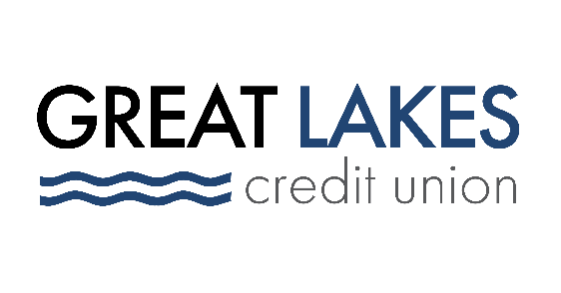

www.glcu.org
FOR IMMEDIATE RELEASE | Contact: Media Department  media@glcu.org  (847) 578-7324
Great Lakes Credit Union Celebrates National Random Acts of Kindness Day

BANNOCKBURN, IL (Feb. 22, 2022) – On Thursday, Feb. 17, Great Lakes Credit Union (GLCU) participated in National Random Acts of Kindness Day by surprising customers at gas stations with fuel. Throughout the day, employees went to five local gas stations near five GLCU branches to pay for a lucky person’s gas. The act of kindness also included a gift card for that person to pay it forward for someone else.

The GLCU participating branches included – North Chicago, Chicago Uptown, Round Lake Beach, Country Club Hills, and Bolingbrook. The purpose behind Random Acts of Kindness Day is to cultivate feelings of kindness and brighten up someone’s day.

“We are committed to the philosophy of ‘People Helping People’,” said Abraham Santiago Senior Manager of Community and Financial Education programs. “What better time to do this than on a day that is dedicated to acts of kindness. Our goal is to create a ripple effect that brings more good into people's lives and creates positive change.”

GLCU allotted $1,000 to charitable giving for Random Acts of Kindness Day.

“You never know who is in need or what someone is going through,” said Cindy Piedra, Assistant Branch Manager at GLCU Chicago Uptown Branch. “GLCU providing this kind gesture really surprised people and put a smile on their faces.”

GLCU is pleased to participate in a movement that promotes and celebrates kindness across the world. We are committed to financial empowerment for everyone and giving back to its communities is one of the credit union’s core values.

About Great Lakes Credit Union
Founded in 1938 and headquartered in Northern Illinois, GLCU is committed to financial empowerment for you. As a not-for-profit financial cooperative with over $1 billion in assets, GLCU is proud to serve more than 80,000 members in the Chicagoland and surrounding areas. Learn more about GLCU’s accounts, educational initiatives and community development programs at glcu.org

