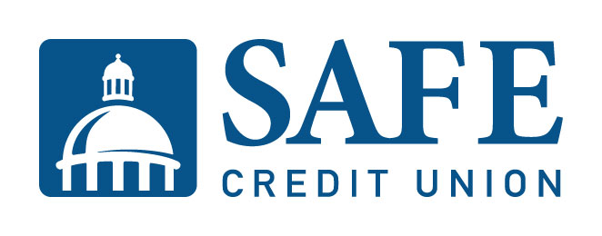

MEDIA INFORMATION For Immediate Release
Contact: Micah Grant
AVP Communications and
Public Relations
SAFE Credit Union
(916) 971-2260 – w
(323) 868-9067 - c

SAFE Credit Union Selects its First Woman President/CEO, Faye Nabhani

FOLSOM, Calif. – (November 18, 2021) – SAFE Credit Union announced today that Dave Roughton will retire as President and CEO effective December 31, 2022. Roughton will be succeeded by Executive Vice President/Chief Credit Officer Faye Nabhani, who will be the first woman President/CEO in the credit union’s history.

“On behalf of SAFE Credit Union, thank you to Dave Roughton for his vision and leadership to build a strong credit union and position it for success into the future,” said Terrance Tremelling, Chair of the SAFE Credit Union Board of Directors. “SAFE has been fortunate to have Dave at the helm for the past six years. Under his stewardship, SAFE doubled in size from $2.14 billion to over $4.3 billion, and from 192,000 members to more than 240,000. Dave also led a momentous investment in the Greater Sacramento region by partnering with the City of Sacramento to secure the naming rights to the SAFE Credit Union Convention & Performing Arts District.”

Roughton also inaugurated diversity, equity, and inclusion initiatives at SAFE; expanded technological solutions benefiting the credit union and its members; and deepened the credit union’s influence on the community through expanded philanthropic and advocacy measures. Roughton further strengthened SAFE’s ties to the regional business community through serving as Chair of the Sacramento Metropolitan Chamber of Commerce and as a board member of the Greater Sacramento Economic Council. He fostered a workplace culture that led SAFE being named a Best Place to Work in the Sacramento region for four years in a row.

“It has been an immense pleasure serving SAFE Credit Union, our members, and our employees through these amazing years of growth,” Roughton said. “My leadership philosophy centered on the principle of putting people first, always. Faye joins me in supporting SAFE’s mission of delivering financial health for all. Her executive experience, warm leadership style, and clear vision will successfully take SAFE into its next era.”
Faye Nabhani joined SAFE in 2016 as Executive Vice President/Chief Credit Officer, overseeing the credit union’s successful lending programs, including mortgage, auto, credit, and commercial. During her tenure, she oversaw a 52% growth in SAFE’s loan portfolio. She accomplished this remarkable growth with minimal FTE increases by consolidating loan operations around the organization into one team structure. She also implemented technological upgrades to facilitate online loan applications. In response to the economic impact of the COVID-19 pandemic, Nabhani led efforts that provided more than $250 million in assistance to SAFE members through no- and low-interest emergency loans, forbearance, partial payment programs, waived fees, and the Paycheck Protection Program.
Faye provides organizational leadership, strategic vision, and lending expertise as a key member of SAFE’s Executive Management Team. Faye is also the strategic leader and executive sponsor of SAFE’s core system conversion to Fiserv DNA, which will be completed in April 2022. As part of the leadership transition, Nabhani will become President as of January 1, 2022, and take on the combined President/CEO role on January 1, 2023. She will be the first woman President/CEO in SAFE’s 80-plus-year history.
“I am deeply honored to be the next President/CEO of SAFE Credit Union,” Nabhani said. “SAFE is a strong credit union and key corporate citizen in the region. I look forward to continuing to find new and innovate ways to better serve SAFE’s members. SAFE will always be a partner to our community through philanthropy, corporate engagement, and by providing financial health to our members. Dave has pushed SAFE to new heights and I’m looking forward to guiding it through its next chapter.”
Prior to joining SAFE, Faye worked for KeyPoint Credit Union in Santa Clara, California, for 22 years in a variety of credit operations and management positions, including most recently as their Chief Lending Officer. Faye has served as a member of various boards of directors, including MBL LLC (now CUBG), as an Executive Committee Member of the Credit Union National Association Lending Council, and as a board member of the Folsom Tourism and Economic Development Corporation (2016-2018).

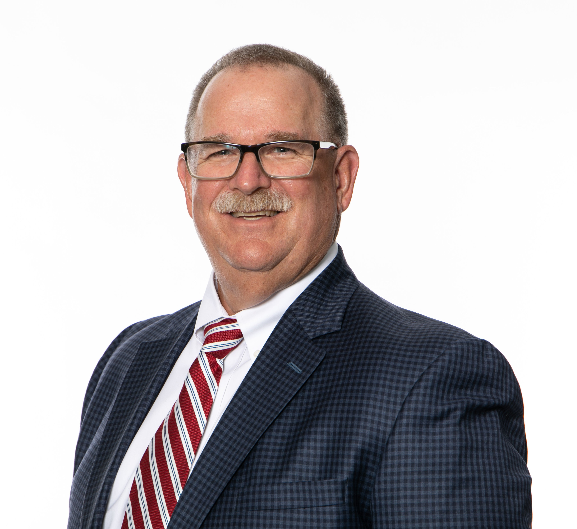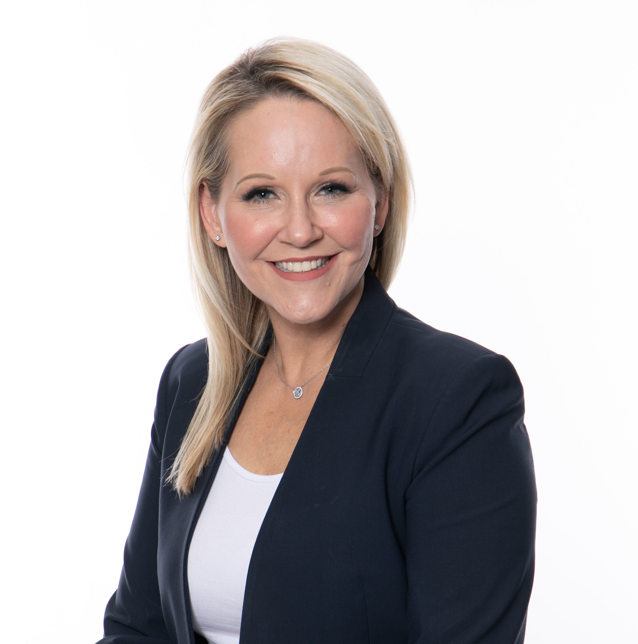
SAFE Credit Union Executive Vice President/Chief Credit Officer
Faye Nabhani
Dave Roughton
SAFE Credit Union President and CEO Dave Roughton

About SAFE
SAFE Credit Union has made members an integral part of its vision since 1940. Over the years the credit union has kept the focus on what really matters, putting members first, a formula that has seen SAFE grow into a leading financial institution in Northern California with over $4 billion in assets and over 240,000 members. SAFE crafts every cutting-edge product and sterling service with members’ needs foremost in mind. In addition to banking services conveniently available through online, chat, mobile, or phone options, SAFE offers in-person services for members and small businesses at service centers across the Greater Sacramento region. SAFE is a not-for-profit, state-chartered credit union with membership open to businesses and individuals living or working in Sacramento, Placer, Yolo, El Dorado, Sutter, Butte, Nevada, Solano, San Joaquin, Contra Costa, Yuba, Amador, and Alameda counties. Insured by NCUA. www.safecu.org

