FOR IMMEDIATE RELEASE:
Laura Mugge
lmugge@escu.org | 314-650-2699
https://www.electrosavings.com/

PAT PETTEY NAMED TO THE SMALL BUSINESS MONTHLY LIST OF TOP BUSINESS ADVISORS IN ST. LOUIS

ST. LOUIS, MO (February 18, 2022) Pat Pettey, Business Relationship Manager for Electro Savings Credit Union, has been named to the Small Business Monthly (SBM) list of top business advisors in St. Louis. The list, which represents the thoughts and advice from the area’s best advisors, was released on February 4, 2022.

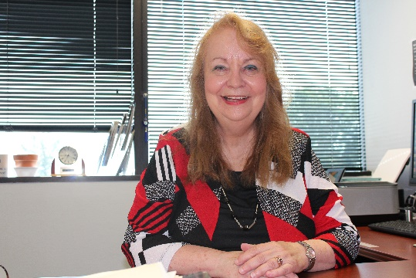
Pettey joined the Electro Savings team over 12 years ago; she previously served as vice president of the business banking group at a large local community bank. “The consulting, caring nature of the philosophy of Electro Savings is what won me over,” says Pettey. “In my position, I have to be very creative. No two business members are the same, so we constantly throw out new ideas and come up with answers that will help each member reach their goals.”

Pettey is still putting her creative mind to good use when she isn't working. She's a published writer, enjoys drawing, and keeps busy as a pastor's wife and grandmother.

If you’re interested in learning more about Electro Savings’ business products and services, visit their website, stop by a branch, or call (314) 434-6470, ext. 1406.

###

About Electro
Established in 1941 by the employees of Union Electric Company (now Ameren), Electro Savings Credit
Union is a full-service, not-for-profit cooperative financial institution. In addition to its Maryland Heights, St. Peters, Manchester, and South County offices, Electro Savings members may access their accounts online, in a mobile app, and at CO-OP ATMs and Shared Branches. Membership in Electro Savings Credit Union is available to individuals who live or work in St. Louis City and County, St. Charles, Franklin, and Jefferson counties in Missouri, and Jersey, Madison, St. Clair, and Monroe counties in Illinois. Electro Savings also offers business services, business loans, and a no-cost employee benefits program to local businesses. To learn more, visit www.electrosavings.com.

