FOR IMMEDIATE RELEASE

Southland Credit Union donates over $100,000 in computer equipment to the City of Long Beach Parks, Recreation and Marine Bureau

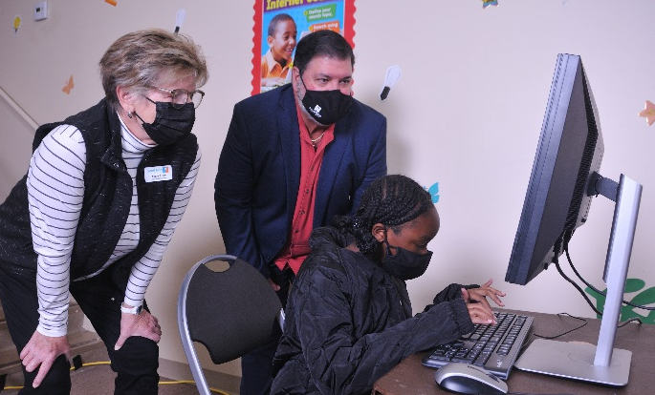
Los Alamitos, CA (February 26, 2020) — Southland Credit Union has donated more than $100,000 in computer workstations, including equipment and software, to the City of Long Beach Parks, Recreation and Marine Department (PRM), which will support the City’s after school, teen and senior programs and the Community Learning Hub Program.
The donated computer workstations include more than 200 monitors, keyboards, hard drives and Windows 10 software licenses, which are in the process of being distributed to City community centers that offer recreation programs.
Pictured: Southland Credit Union Board Director Angie Avery and President/CEO Tomas Lent accompany a Long Beach-area student as she does schoolwork on a donated workstation at the Martin Luther King Park Community Center.

“Partners like Southland Credit Union provide valuable support for PRM programs and the Department’s ability to best serve the community,” said Brent Dennis, director of Parks, Recreation and Marine. “Their donation will make a positive impact on local youth.”
The workstation donation is part of the credit union’s ongoing effort to support the Long Beach Community. Southland is also the Official Credit Union of Long Beach State Athletics, providing sponsorship funds to the university under a multi-year agreement. After the opening of the Southland Credit Union Long Beach branch in December 2018, the credit union made a commitment to finding ways to give back to the city.
“The credit union movement is committed to the philosophy of ‘people helping people,’ and Southland is honored to have the opportunity to partner with the City of Long Beach in a way that will positively impact the community,” said Tom Lent, President and CEO of Southland Credit Union. “As a Long Beach native, I am looking forward to Southland forging a lasting partnership with the City of Long Beach.”
The workstations will be available at a later date to registered youth and seniors of the City’s after school, teen and senior programs as well as for virtual learning and activities through the Long Beach Unified School District.
###

About Southland Credit Union
Southland Credit Union is a $981 million credit union that serves 60,000 members in Orange and Los Angeles Counties. Branch locations are in Long Beach, Los Alamitos, Downey, Carson, Santa Monica, St. John’s Health Center and the Los Angeles Federal Building in downtown Los Angeles.
Operating as a not-for-profit financial cooperative, Southland is dedicated to providing our Members with exceptional, comprehensive and innovative financial solutions, delivered with uniquely personal Southland service. For more information, visit www.southlandcu.org.
Contact
Matthew Herrick
SVP, Marketing & Financial Services
562.936.8713 • mherrick@southlandcu.org

About the City of Long Beach
Home to approximately 480,000 people, the multiple award-winning and innovative City of Long Beach offers all the world-class amenities of a large metropolitan city while maintaining a strong sense of individual and diverse neighborhoods nestled together along the California coast. As a full-service charter city, Long Beach is home to the Queen Mary, Aquarium of the Pacific, several museums and theaters, a highly rated school district, Long Beach Airport and the Port of Long Beach. The City also has a highly respected university and city college, two historic ranchos, five hospitals, five golf courses, 171 parks, miles of beaches, marinas and bike paths.
For more information about the City of Long Beach, visit http://longbeach.gov/. Follow us on social to keep up with the latest news: Facebook, Twitter, Instagram and YouTube.
About Long Beach Parks, Recreation and Marine
Long Beach Parks, Recreation and Marine Department (PRM) is recognized for excellence in management practices and programs, having received the National Parks and Recreation Association Gold Medal Award four times. PRM provides leisure programs and services to residents and visitors, which improve the quality of life in Long Beach. PRM maintains 171 parks with 26 community centers, 320 acres of open space and 6.1 miles of beaches; implements the City's Open Space Plan; provides recreational opportunities to meet diverse community needs; maintains public marinas; and provides for public safety and the humane treatment of animals.
For more information about the Long Beach Parks, Recreation and Marine, visit http://www.longbeach.gov/park. Follow us on social to keep up with the latest news on Facebook, Twitter, Instagram and YouTube.

