News Release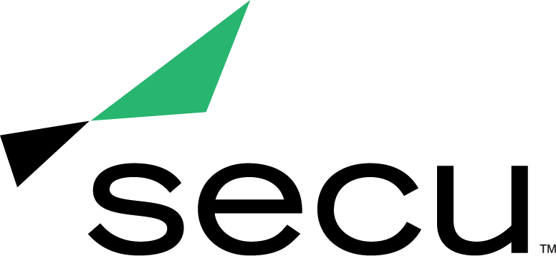

**SECU MD Wins Two Prestigious MX Awards**

*The American Marketing Association Baltimore Chapter Honors SECU for**Kindness Campaign & Brand Refresh*

**BALTIMORE** (June 11, 2021) —[SECU](https://www.secumd.org/), Maryland’s largest state chartered credit union, is pleased to announce it has won two MX Awards from the American Marketing Association Baltimore Chapter (AMA Baltimore). For 36 years, the MX Awards have honored area companies and organizations that exemplify outstanding marketing creativity, execution and campaign-driven results.

“We are proud and honored to have won awards in two categories during the 2021 MX Awards,” said Becky Smith, EVP and chief strategy & marketing officer for SECU Maryland. “Winning Best Event Marketing Campaign of the Year and Best New Brand Identity Campaign of the Year is a testament to the unmatched creativity and tireless work ethic our team has put forth. Our community came together in 2020 to celebrate our KindnessU campaign and brand refresh. This recognition is proof of their support.”

SECU’s Kindness Campaign, KindnessU, received the Best Event Marketing Campaign of the Year award. The month-long event worked to generate kindness within the community while raising funds to support the SECU MD Foundation. KindnessU encouraged members and staff to commit acts of kindness in an effort to inspire others to likewise conduct an act of kindness, growing the impact of kindness exponentially across the state of Maryland.

With this mission in mind, SECU created and distributed free “Kindness Kits” to both members and the general public. Each kit contained supplies to perform several random acts of kindness. Through this campaign, SECU distributed 1,300 Kindness Kits, completed a total of 6,176 acts of kindness and raised $50,000 for the SECU MD Foundation.

With support from their local agency partner [Planit](https://planitagency.com/), SECU’s brand refresh campaign also took home the Best New Brand Identity Campaign of the Year award. An expanded color palette, new imagery and a modernized logo revealed in the 2020 “Here’s to the Seekers” campaign reflect on the organization’s heritage while more aptly signifying SECU’s evolution over the past 70 years to providing holistic financial options for those looking for a better banking experience.

All aspects of the reimagined brand appearance communicate the organization’s understanding that members choose brands that do what is right rather than what is easy. SECU’s commitment and approach to financial wellness are founded on the principles of taking the extra step for members, nurturing personal connections and always choosing to do the right thing.

To learn more about AMA Baltimore’s 2021 MX Awards, visit <https://amabaltimore.org/ama-baltimore-announces-the-winners-of-the-2021-mx-awards/>.

**About SECU (State Employees’ Credit Union of Maryland)**

*SECU* (“*see-Q”), Maryland’s largest state-chartered credit union, serves 260,000 members across the state. As a member-owned not-for-profit, SECU puts its members first. Membership is open to all Maryland state employees and their families, University System of Maryland students, graduates, staff and their families, Bank At Work partners and many others. Headquartered in Linthicum, Maryland, SECU has 22 financial centers and provides access to 30,000 free ATMs through the CO-OP network. With more than $4 billion in assets, SECU ranks among the top 60 credit unions nationwide based on total assets in the U.S. insured by NCUA. For more information, visit* [*www.secumd.org*](http://www.secumd.org/) *or follow SECU on* [*Twitter,*](https://twitter.com/secuMD) [*Facebook*](https://www.facebook.com/secuMD) *and* [*Instagram*](https://www.instagram.com/secumd/)*.*

###

**Media Contact**

Kelly Nguyen

[knguyen@planitagency.com](mailto:knguyen@planitagency.com)

609-385-6701