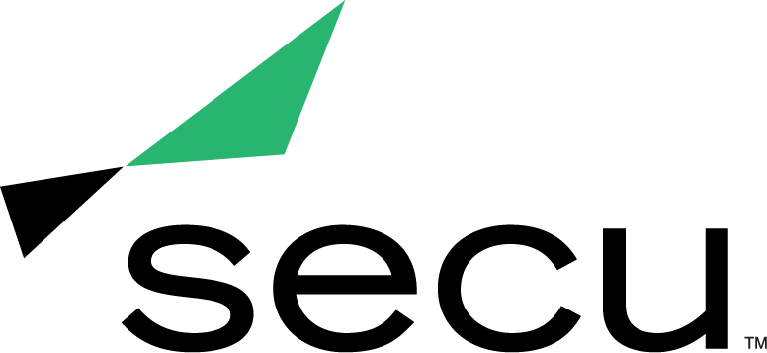
News Release

LINDA BERNSTEIN NAMED 2021 CREDIT UNION ROCK STAR
Credit Union Magazine honors SECU’s Social Media Marketing Specialist as outstanding credit union professional

BALTIMORE (Sept. 28, 2021) – Linda Bernstein, Social Media Marketing Specialist at SECU - Maryland’s largest state chartered credit union, was named a 2021 Credit Union Rock Star by Credit Union Magazine.

The Credit Union Rock Stars program honors exceptional credit union professionals and volunteers from a wide range of disciplines, who demonstrate their unique strengths to advance the mission of their credit union. This year’s winners were selected for their exceptional creativity, innovation and passion.

“Linda is an essential part of our marketing team and has propelled SECU’s social media presence from simply existing to a now thriving and engaging online community,” said Becky Smith, EVP and Chief Strategy & Marketing Officer of SECU. “Embodying SECU’s values through and through, Linda demonstrates a commitment and connection with SECU members that goes above and beyond.”

Since joining SECU, Bernstein has grown SECU’s social media following by 40 percent through creative gateways, financial education and resources, and timely updates on the stories that matter most. As a result of Bernstein’s passion and expertise, The Financial Brand named SECU as one of the Top 100 Credit Unions Using Social Media in the country.

As Social Media Marketing Specialist, Bernstein oversees SECU’s social channels and digital presence, creating and managing impactful content that supports and engages members.

Sponsored by Fiserv, this year’s Credit Union Rock Stars will be featured in an upcoming digital issue of Credit Union Magazine.

For more information about CUNA’s 2021 Credit Union Rock Star program, visit https://news.cuna.org/rockstar.

About SECU (State Employees’ Credit Union of Maryland)
SECU ("see-Q"), Maryland’s largest state chartered credit union, serves 250,000 members across the state. As a member-owned, not-for-profit, SECU puts its members first. Membership is open to all Maryland state employees and their families, University System of Maryland students, graduates, staff and their families, Bank At Work partners and many others. Headquartered in Linthicum, Md., SECU has 24 financial centers and provides access to over 50,000 free ATMs through the CO-OP network. With more than $4 billion in assets, SECU ranks among the top 60 credit unions nationwide based on total assets in the U.S. Insured by NCUA. For more information, visit www.secumd.org or follow SECU on Twitter, Facebook and Instagram.

###

