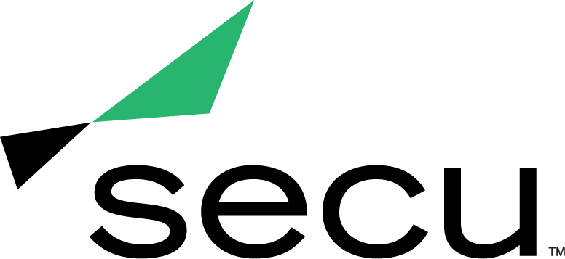
News Release

SECU WINS INTERNATIONAL BANKING AND CREDIT UNION MARKETING AWARD FOR KINDNESS CAMPAIGN
Gramercy Institute honors SECU for excellence in Experiential Marketing

BALTIMORE (Aug. 16, 2021) – SECU, Maryland’s largest state chartered credit union, was awarded a 2021 Banking and Credit Union Marketing Award (BCUMA) from the Gramercy Institute for its 2020 Kindness^{U} fundraising campaign within the Experiential Marketing category. These awards honor leaders from the world's banking and credit union marketing industry and the value they bring to their clients and the industry.

Last October as nonprofits quickly adapted to a changing event landscape due to necessary pandemic safety precautions, SECU launched a month-long fundraising campaign to spread kindness across Maryland, while also raising funds to support the SECU MD Foundation and its programs that increase access to education, health and wellness, and community development across the state.

Kindness^{U} encouraged Marylanders to perform random acts of kindness with the goal of inspiring others to do the same, causing a ripple effect across the state. To assist in this effort, SECU created and distributed Kindness Kits, which contained supplies to perform kind acts at home or in the community, to members and the general public at no cost. SECU also hosted a culminating “Day of Kindness” where employees, members and partners could perform acts of kindness using their Kindness Kits.

As a result of the campaign, SECU successfully raised $50,000 for the SECU MD Foundation and exceeded its goal with 1,300 Kindness Kits distributed and more than 6,000 acts of kindness performed.

“Last year, we saw our communities, employees and members face unprecedented challenges due to the pandemic, and without hesitation, we knew we needed to offer help unlike ever before. Kindness^{U} was rooted in the idea that each of us has the ability to empower and support others,” said Becky Smith, Chief Strategy and Marketing Officer of SECU. “Receiving the Experiential Marketing award for our kindness campaign brings our team a tremendous sense of accomplishment. We look forward to bringing back our kindness initiative annually and watching its impact grow exponentially, starting with this year's campaign, Kindness Connects, as we seek to perform 70,000 acts of kindness."

BCUMA exclusively evaluates banking and credit union marketing work according to creative excellence, media planning, marketing strategy, experiential marketing, public relations and other benchmarks of bank and credit union marketing success. Judging was carried out by a panel of financial services marketing leaders from the world’s top financial, media and marketing brands.

To view the complete list of 2021 Banking & Credit Union Marketing Award winners, visit https://www.gramercyinstitute.com/bcuma-winners-2021.

About SECU (State Employees’ Credit Union of Maryland)
SECU ("see-Q"), Maryland’s largest state chartered credit union, serves 250,000 members across the state. As a member-owned, not-for-profit, SECU puts its members first. Membership is open to all Maryland state employees and their families, University System of Maryland students, graduates, staff and their families, Bank At Work partners and many others. Headquartered in Linthicum, Md., SECU has 24 financial centers and provides access to over 50,000 free ATMs through the CO-OP network. With more than $4 billion in assets, SECU ranks among the top 60 credit unions nationwide based on total assets in the U.S. Insured by NCUA. For more information, visit www.secumd.org or follow SECU on Twitter, Facebook and Instagram.

###

