NEW ENGLAND FEDERAL CREDIT UNION
141 Harvest Lane
Williston VT 05495
nefcu.com
facebook.com/NEFCUVT
twitter.com/NEFCU

NEFCU News Release
March 1, 2021
Contact: Bill Smith, Chief Marketing and Retail Officer; (802) 879-8705; smith@nefcu.com

Photo Caption, l to r: Laura Hamlin, NEFCU Marketing Communications Specialist; Alicia Tanneberger; Andrew Nagy, NEFCU Marketing Administrator

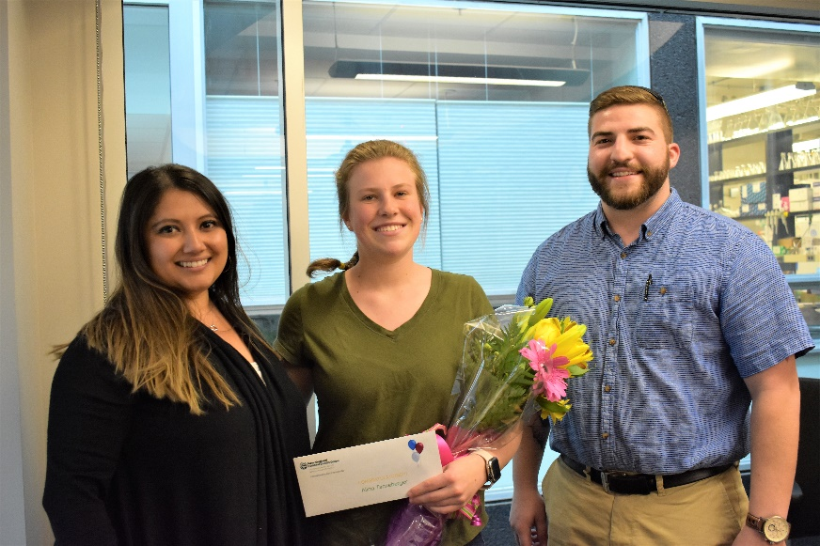

New England Federal Credit Union
Accepting Applications for 2021 STEM Scholarships

Williston, VT—New England Federal Credit Union (NEFCU) is accepting applications for its 2021 Science, Technology, Engineering, and Mathematics (STEM) Scholarships. Three scholarships of $3,000 each will be awarded.

To be eligible for NEFCU STEM Scholarships, applicants must be New England Federal Credit Union members.

In addition to NEFCU membership, applicants must be pursuing one of these fields of study:

- Biological Sciences
- Physical Sciences
- Mathematical Sciences
- Computer and Information Sciences
- Geosciences
- Engineering
- Technology areas associated with the preceding fields of study.

Scholarships will be awarded to applicants who best demonstrate commitments to their fields of study. Application forms will be available online at nefcu.com, at any branch, or by calling 802-879-8790. Completed applications must be postmarked no later than April 30, 2021. The mailing address is Scholarship Committee, NEFCU, P.O. Box 527, Williston, VT 05495

New England Federal Credit Union (NEFCU), headquartered in Williston, Vermont is a member-owned financial institution serving communities in twelve counties of Vermont: Addison, Bennington, Caledonia, Chittenden, Franklin, Grand Isle, Lamoille, Orange, Rutland, Washington, Windham, and Windsor; and four counties in New Hampshire: Cheshire, Grafton, Merrimack, and Sullivan. For more information about membership requirements and benefits, visit nefcu.com.

-30-

