United Federal Credit Union – Press Release
March 1, 2022

Contact: Diana Wake
Phone: (888) 982-1400 ext. 6891
Email: dwake@UnitedFCU.com
United Federal Credit Union, 150 Hilltop Road, St. Joseph, Michigan, 49085

United Federal Credit Union Branch Manager Named Southwest Michigan Regional Chamber’s Ambassador of the Year
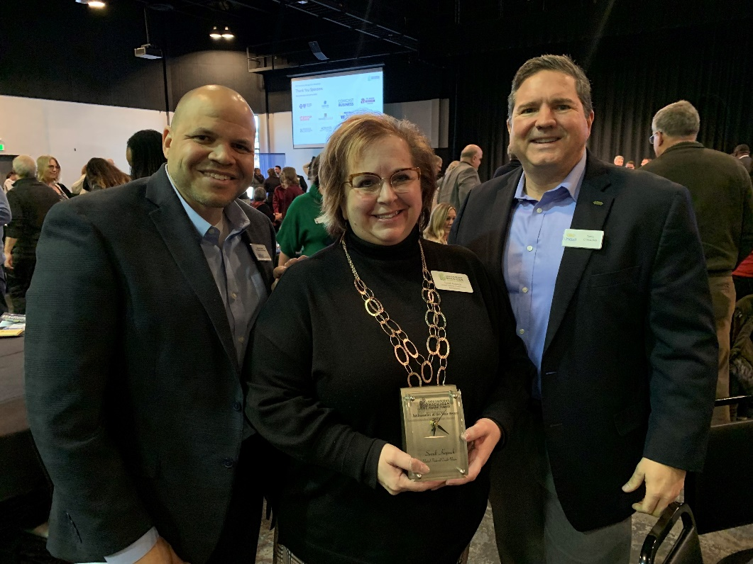
Sandi Kopach (center) with James Knight, Chief Sales and Service Officer (left) and Terry O’Rourke, President/CEO (right)

ST. JOSEPH, Mich. – United Federal Credit Union (United) is pleased to announce Sandi Kopach was named Southwest Michigan Regional Chamber’s Ambassador of the Year for 2021. Kopach is the branch manager at United’s branch at 4097 Hollywood Rd. in Royalton Township.

“This is such an honor to be recognized by the Chamber as the Ambassador of the Year. It means even more knowing it is voted on by the other Ambassadors,” said Kopach. “I love the way the Chamber brings the community and local businesses together! There is a lot of hard word that goes in to opening a new business and the Chamber supports them through their journey.

“We are so excited for Sandi to receive this recognition from the Chamber,” said Jodie Kitchell, United District Manager. “She leads by example every day not only with her branch team, but within the entire southwest Michigan community.”

Kopach has more than 20 years of banking experience in Berrien County. According to the Chamber, “she values building relationships, offering exceptional customer service, connecting on a personal level, and helping Members achieve their financial goals.”

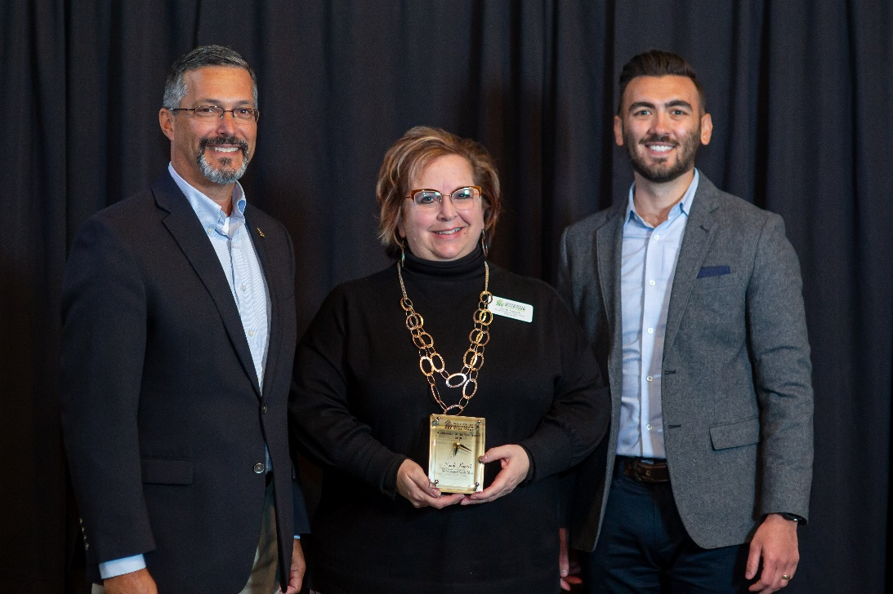
Sandi Kopach (center) with Mark Lemoine, Southwest Michigan Regional Chamber Board Chair (left) and Arthur Havlicek, Southwest Michigan Regional Chamber President and CEO (right)

“The Ambassador of the Year Award is different from any of our other awards being that the individual selected is chosen by their fellow Ambassadors,” said Sarah Spoonholtz, Director of Membership and Events. “Sandi has a well-established track record and reputation for being an active volunteer in the community. She joined our Ambassador team back in 2018 and has been a pleasure to work with and have as part of our team.”

In addition to being an ambassador for the Southwest Michigan Regional Chamber, Kopach volunteers and is a Board Member for Junior Achievement Berrien and Cass County, and volunteers with United Way of Southwest Michigan.
____________
About United
United Federal Credit Union has served its Members since 1949 by helping them to build a sound financial future. United consists of more than 191,000 Member/owners worldwide and manages assets in excess of $3.8 billion. Its corporate office and main branch are in St. Joseph, Mich., with additional branches in Arkansas, Indiana, Michigan, Nevada, North Carolina, and Ohio. Federally insured by NCUA. Equal opportunity lender. Equal housing lender. For more information visit UnitedFCU.com

# # #

