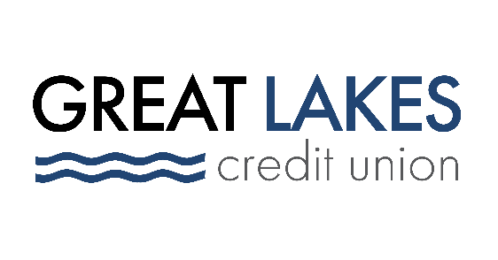

www.glcu.org
FOR IMMEDIATE RELEASE | Contact: Media Department  media@glcu.org  (847) 578-7310
Great Lakes Credit Union Announces Expanded Scholarship Opportunities

BANNOCKBURN, IL (Mar. 8, 2022) – Today, Great Lakes Credit Union (GLCU) announced that applications for its 2022 Member Scholarship Program are now open. This year, GLCU is expanding the program by awarding six members each with a $2,500 scholarship.

GLCU has a long-standing history of service to its communities. The scholarship is one of the credit union’s annual initiatives that supports the financial and educational empowerment of its members.

“Our scholarship benefits students in all life stages, from high school to seasoned career employees,” said Steven Bugg President and Chief Executive Officer.

“The one thing all applicants to the program have in common is a passion for changing the world by furthering their education and we are pleased to invest in their future growth and development.”

Applicants are required to submit the following to be considered for the scholarship:
  - A minimum cumulative grade point average of 2.5
  - Copy of school transcripts
  - Video answering prompt (3 minutes max.)
  - Two letters of reference
  - Completed online form
  - Must be a GLCU member at the time of application

Applications will be accepted through April 30, 2022, and winners will be selected in May. They will receive their scholarship, plus an invite to an awards ceremony this summer. For more information about the 2022 GLCU Scholarship Program, visit https://www.glcu.org/scholarship.

About Great Lakes Credit Union
Founded in 1938 and headquartered in Northern Illinois, GLCU is committed to financial empowerment for you. As a not-for-profit financial cooperative with over $1 billion in assets, GLCU is proud to serve more than 80,000 members in the Chicagoland and surrounding areas. Learn more about GLCU’s accounts, educational initiatives and community development programs at glcu.org

