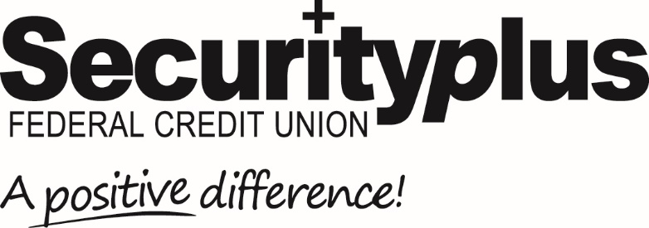
For Release: Immediate Contact: Lisa Allender
410-281-6248
lisa.allender@securityplusfcu.org

Securityplus Federal Credit Union Announces
Merger Approval by FIAFE Federal Credit Union

Baltimore MD (November 23, 2021) Securityplus Federal Credit Union, headquartered in Baltimore, Maryland has announced that members of Friendship International Airport Federal Employees (FIAFE) Federal Credit Union voted unanimously to merge with Securityplus on November 19, 2021.

FIAFE, has assets totaling $5.92 million and approximately 390 members. It’s Board
of Directors sought a merger partner with a larger credit union which could offer its members additional banking services and products including online and mobile banking, access to a nationally based network of ATMs, free checking, home mortgages and more.

“We are excited to welcome our new members from FIAFE,” stated interim Chief Executive Officer and Chief Information Officer Mike Keener, “and pleased that we can offer them new service technologies and product offerings to better serve them.”

With the merger vote, FIAFE has closed its sole branch location at BWI Thurgood Marshall Airport.

Securityplus Federal Credit Union is a $500 million not-for-profit, member-owned, full service financial institution, with six branches. Founded in 1938, Securityplus is one of the largest credit unions in Maryland, with over 34,000 members in the greater Baltimore community. For more information on Securityplus history, upcoming events, products and services, and more, visit securityplusfcu.org.

# # # #

