United Federal Credit Union – Press Release
January 26, 2021

Contact: Matt Orlando
Phone: (888) 982-1400 ext. 1473
Email: morlando@unitedfcu.com
United Federal Credit Union, 150 Hilltop Road, St. Joseph, MI 49085

United Federal Credit Union Names Ted Strawbridge
Mortgage Advisor in Niles, MI

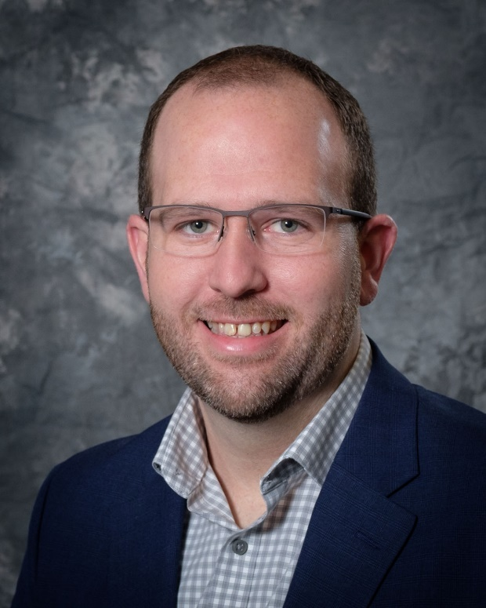
Ted Strawbridge, Mortgage Advisor in Niles, MI

NILES, Mich. – United Federal Credit Union (United) is pleased to announce the appointment of Ted Strawbridge as Mortgage Advisor at United’s Niles South branch at 2100 South 11th Street.

Strawbridge will provide quality real estate lending expertise through financial counseling and product awareness to credit union members regarding their real estate financing needs and generate investment quality mortgage loans.

Strawbridge brings years of banking and customer service experience to his new role. He has held many positions with United, including serving as a Member Service Advisor and as a Member Service Advisor with the Loan Queue team.

Most recently, Strawbridge served as United’s Member Sales & Service Center Manager at the Buchanan branch where he was responsible for ongoing support of the sales and service culture to enhance the member experience and for daily problem resolution, process improvement, and department efficiency.

____________

About United
United Federal Credit Union has served its Members since 1949 by helping them to build a sound financial future. United consists of more than 177,000 Member/owners worldwide and manages assets in excess of $3.2 billion. Its corporate offices and main branch are in St. Joseph, Mich., with additional branches in Arkansas, Indiana, Michigan, Nevada, North Carolina, and Ohio. Federally insured by NCUA. Equal opportunity lender. Equal housing lender. For more information visit www.unitedfcu.com

# # #

