FOR IMMEDIATE RELEASE  DATE  CONTACT:  Glen Stacey  518-730-9044  glen.stacey@sunmark.org | 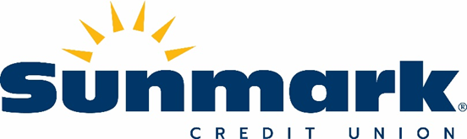

Sunmark Credit Union Promotes Toni LeBron to Executive Vice President and Chief Operating Officer

(Latham, N.Y.) Sunmark Credit Union announced today that Antoinette (Toni) LeBron has been promoted to Executive Vice President and Chief Operating Officer. In this expanded role, Toni works directly with President and CEO Frank DeGraw in leading the ideation and implementation of strategic objectives for the credit union, spearheading key initiatives related to continued member and employee growth and development. Her responsibilities include operations, information technology, risk and compliance, member relations, and human resources, as well as Sunmark’s Life Stage Advisory program and SIS Insurance.

Toni holds more than 35 years of progressive financial institution management experience. Prior to joining Sunmark Credit Union in 2006, Toni spent more than five years at New York State Credit Union League – CUC Services, Inc., where she served as an executive account manager. Before that, she worked in various leadership roles at Fleet Bank of New York for over a decade, including vice president, district manager, and senior field sales specialist.

As a member of the Sunmark executive leadership team, Toni frequently donates time and resources to supporting the Sunmark Charitable Community Foundation. She also serves as the President of Horizon Service Organization, LLC, the credit union service organization (CUSO) for Sunmark Credit Union.

“Throughout her tenure at Sunmark, Toni has played an instrumental role in our continued growth and success,” said Frank DeGraw, President and CEO of Sunmark Credit Union. “Under her leadership, Sunmark has implemented numerous services, products and resources designed to serve our members, our employees, and our communities. Her dedication and commitment to Sunmark is truly unparalleled, and I am looking forward to our continued collaboration in this expanded capacity.”

###
About Sunmark Credit Union: Since 1937, Sunmark Credit Union ($810 million in assets; 65,500+ members) has been helping members improve their financial position. Sunmark is committed to the financial health and well-being of each member by offering tools that educate and inform and products and services that make it easier to reach financial goals. For more information, call 518-382-0605 or visit www.sunmark.org.

