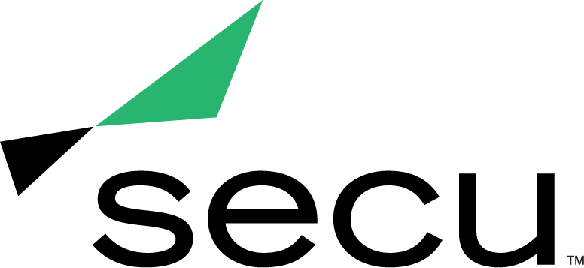
News Release

SECU WINS THE BALTIMORE SUN’S TOP WORKPLACES 2021 AWARD
The Baltimore Sun names SECU a top workplace based on exceptional employee feedback

BALTIMORE (Dec. 20, 2021) – SECU, Maryland’s largest state chartered credit union, was awarded a Top Workplaces of 2021 title by The Baltimore Sun. The honor is determined by employee feedback gathered by anonymous survey technology partner Energage, LLC. The survey measures employee satisfaction in several sectors of workplace culture including pay and benefits, flexibility, purpose and connection.

The Baltimore Sun annually honors the region’s top workplaces, with 2021 being the news outlet’s 11th year offering this title. These awards highlight employers in the Baltimore area that provide an extraordinary work environment, inspire and motivate their employees. Employers are recognized for this honor when their employees share positive experiences about workplace culture through the anonymous survey.

“At SECU, we are proud to be an organization that prioritizes creating a culture that provides support and engagement with our employees,” said Teshia Davis, vice president of people and culture at SECU. “Investing in the employee experience is an integral part of our success here at SECU. We are honored to receive this award as it celebrates SECU’s commitment to our employees.”

To view all 2021 top employers honored byThe Baltimore Sun, visit https://www.baltimoresun.com/business/topworkplaces/, or to learn more about SECU and view current employment opportunities, please visit https://www.secumd.org/about-us/working-at-secu/.

About SECU (State Employees’ Credit Union of Maryland)
SECU ("see-Q"), Maryland’s largest state chartered credit union, serves 250,000 members across the state. As a member-owned, not-for-profit, SECU puts its members first. Membership is open to all Maryland state employees and their families, University System of Maryland students, graduates, staff and their families, Bank At Work partners and many others. Headquartered in Linthicum, Md., SECU has 24 financial centers and provides access to over 50,000 free ATMs through the CO-OP network. With more than $4 billion in assets, SECU ranks among the top 60 credit unions nationwide based on total assets in the U.S. Insured by NCUA. For more information, visit www.secumd.org or follow SECU on Twitter, Facebook and Instagram.

###

MEDIA CONTACT
Kelly Nguyen
knguyen@planitagency.com
609-385-6701

