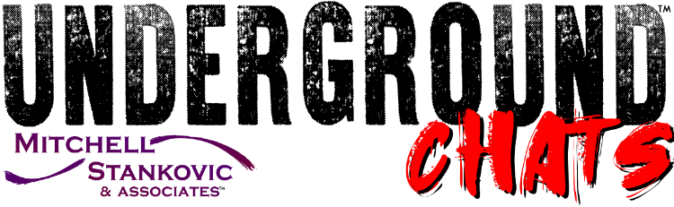
Contact
Zach Christensen
602.390.7655
zach@mitchellstankovic.com

Cheryl Middleton Jones, CO-OP Financial Services, Chats Employee Wellbeing, Diversity and Todd Talks
“Take the opportunity to learn what worked and what did not work during the pandemic,” stated Cheryl Middleton Jones, Chief People Officer at CO-OP Financial Services when speaking with Susan Mitchell, CEO of Mitchell, Stankovic & Associates and Founder of the Underground about the evolving workplace. “Once you stetch a rubber band, it doesn’t go back to the same shape.”
For CO-OP, it’s important employees know what’s happening in and outside the organization. “Our CEO, Todd Clark does a Todd Talk once a week, sharing what’s top of mind and and a company update,” said Middleton Jones. “They make an impact on how employees view what is happening inside CO-OP as well as outside the organization.”

Join us to #STANDUP for credit unions and put Ideas into Action:

- Leverage Your Culture
  - Employees live your culture everyday. Rely on them to identify opportunities for positivity.
- Meet the Moment
  - Understand the role your organization plays in the world and lean in to your culture.

Watch the full Underground Chat
See Cheryl and other thought leaders at the Underground Collision BFO on March 1 from 9-11 am PST where we will look at their blinding flashes of the obvious to think big, act fast and focus on the credit union difference. Register today!
# # #
Mitchell, Stankovic & Associates (MSA) mission is to stand up for issues that will make a difference to a diverse world of people, the bottom line for credit unions and change member lives globally. Clients glow when asked about MSA because they know what a partnership truly means – working together to achieve financial democracy. MSA believes that credit unions have a social purpose, and its advisory services emphasize doing the right thing as good business, garnering sustainable growth and relevance within the market. From CEO Leadership Transitions to Strategic Planning and Director Advisory Services to Modernizing Board Governance, MSA consulting practice has 25 year clients who have become champions to encourage new clients from all over the world. Serial entrepreneurs, MSA consultants have founded industry initiatives like the Underground Movement, Global Women’s Leadership Network, CU Pride, HRD Network and they volunteer on governing bodies of Worldwide Foundation and Credit Union DEI Collective.
CO-OP Financial Services is a payments and financial technology company whose mission is ensuring the success of the credit union movement. CO-OP payments solutions, engagement services and strategic counsel help credit unions optimize member experiences to consistently provide seamless, personalized multi-channel offerings, while delivering secure, sophisticated fraud mitigation service. For more information, visit www.co-opfs.org.

