United Federal Credit Union – Press Release
June 10, 2021

Contact: Diana Wake
Phone: (888) 982-1400 ext. 6891
Email: dwake@UnitedFCU.com
United Federal Credit Union, 150 Hilltop Road, St. Joseph, Michigan, 49085

United Federal Credit Union Donates $7,500 to
Boys & Girls Club of Van Buren after Tornado Damage

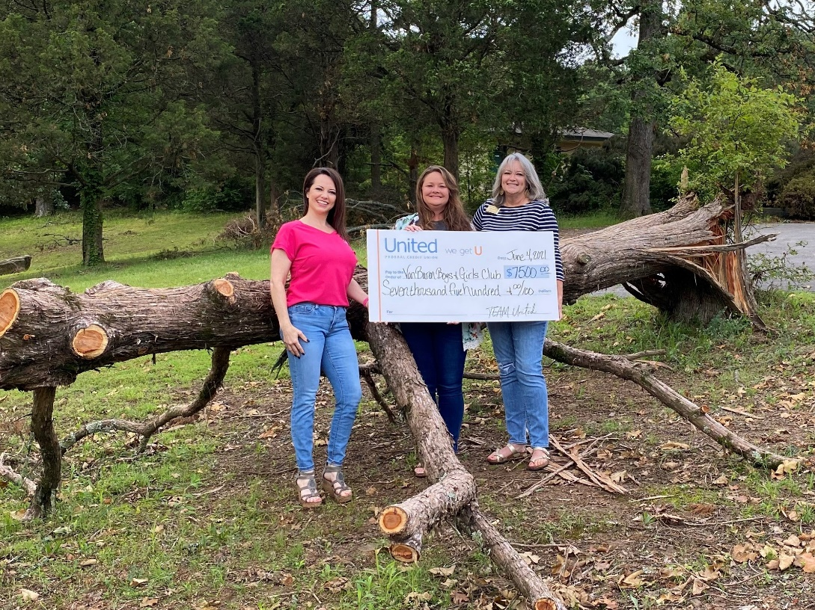
United Federal Credit Union donates $7,500 to the Boys & Girls Club
of Van Buren to help make repairs after tornado damage

VAN BUREN, Ark. – United Federal Credit Union (United) has donated $7,500 to the Boys & Girls Club of Van Buren after a recent tornado damaged its buildings and grounds. The club was in the path of a tornado that hit the area on May 3, 2021.

“When we saw the damage left behind from the tornado, we knew we had to help in any way we could,” said Mishelle Davis, United Regional Market Development Manager. “United has a long-standing partnership with the club and we know how important their programs are for the youth in our area. That’s why we didn’t hesitate when they needed our help. We are proud to be able to live United’s philosophy of ‘people helping people’ and take care of our community in times of need.”

According to the club’s executive director, the club had more than $110,000 in damages. The majority of the damage was in the gymnasium area of their building, a space that is used almost every day.

“The donation from United will help sustain programming throughout the year that would have been omitted due to the reduction of operating funds to cover the repair costs,” said Cindy Faldon, Executive Director for The Boys & Girls Club of Van Buren. “United has been a longtime contributor to our organization and we are so grateful for all they do to support our members and operations.”
____________
About United
United Federal Credit Union has served its Members since 1949 by helping them to build a sound financial future. United consists of more than 180,000 Member/owners worldwide and manages assets in excess of $3.6 billion. Its corporate offices and main branch are in St. Joseph, Mich., with additional branches in Arkansas, Indiana, Michigan, Nevada, North Carolina, and Ohio. Federally insured by NCUA. Equal opportunity lender. Equal housing lender. For more information visit UnitedFCU.com

# # #

