United Federal Credit Union – Press Release
July 29, 2021

Contact: Diana Wake
Phone: (888) 982-1400 ext. 6891
Email: dwake@UnitedFCU.com
United Federal Credit Union, 150 Hilltop Road, St. Joseph, Michigan, 49085

United Federal Credit Union Welcomes Experienced
Commercial Loan Team in Southwest Michigan

ST. JOSEPH, Mich. – United Federal Credit Union (United) has added four new branches in southwest Michigan as part of its acquisition of Edgewater Bank, and with it adds commercial lending expertise that will complement its existing business services team.

Four former Edgewater employees will not only support United’s award-winning commercial lending operations, but also will be able to provide their former Edgewater business clients with more products and services than ever before.

The newest group of commercial lenders offer years of experience in the local community and outstanding service to further enhance lending options for businesses in southwest Michigan.

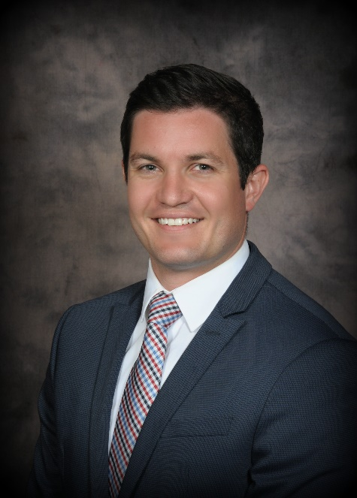
Tim Dyer, Commercial Lending Group Manager

Tim Dyer brings 11 years’ experience in the banking industry to his role as Commercial Lending Group Manager. He was with Edgewater Bank as the Vice President of Commercial Lending for more than five years. Dyer began his career at Edgewater as a Commercial Credit Analyst and Commercial Loan Documentation Specialist before spending more than four years at Fifth Third Bank as a Direct Client Specialist and then in the role of Commercial Loan Closing Specialist. He has a bachelor of arts degree in Business Management from Hope College.

Dyer is active in the southwest Michigan community. He is currently a member of the Southwest Michigan Regional Airport Authority Board, and previously served as a member of the Cornerstone Young Professionals Executive Committee, was a member of the Southwestern Michigan Economic Growth Alliance board, a member of the Harbor Shores Trail Project Committee, and served as a business and finance advisor on a medical mission to Sierra Leone, Africa.

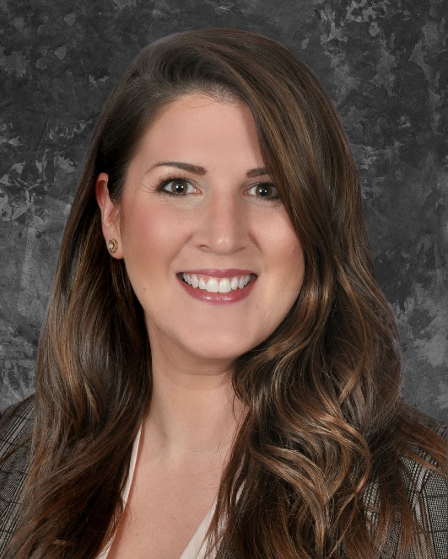
Lisa Hammett, Commercial Loan Officer

Lisa Hammett brings nearly three years’ experience in the banking industry to her role as Commercial Loan Officer. She was with Edgewater Bank since 2019 serving as Commercial Loan Officer. Prior to joining Edgewater, Hammett served as a Special Agent in the United States Air Force for eight years. She has a bachelor’s degree in Finance and Financial Management from Ashford University.

Hammett is passionate about working with other veterans in the Southwest Michigan community. She has volunteered and fundraised for the Berrien County’s Salute to Troops Military Ball, and is a member of the American Legion. Hammett has also volunteered with the United Way, The Wounded Warrior Project, and the Fisher House Foundation which provides housing for military members and their families while receiving on-going medical treatment.

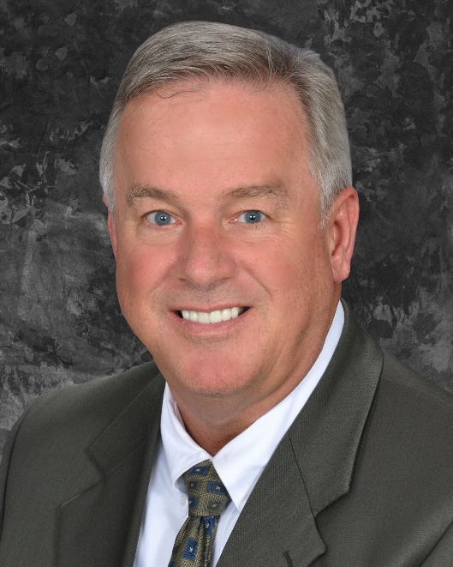
Jeff Hannan, Commercial Loan Officer

Jeff Hannan brings more than 30 years of financial services experience to his role as a Commercial Loan Officer. After spending five years working in work-force development for Berrien, Van Buren and Cass counties, Hannan returned to financial services in 2019, by joining the Edgewater Bank team as a Business Development Officer. He is a graduate of the University of North Carolina – Wilmington with a degree in Business Management.

In the community, Hannan volunteers as a Trustee for Lakeshore Public Schools and serves as the Treasurer. He is also a board member, and past president of the Lakeshore Rotary Club. He previously served on the board for the Cornerstone Chamber of Commerce, was a volunteer teacher with Junior Achievement, and is an active volunteer with the United Way of Southwest Michigan.
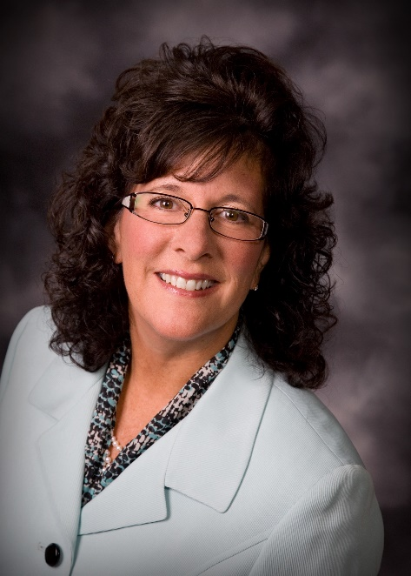
Amy Homich, Commercial Loan Officer

Amy Homich brings 40 years’ financial and banking industry experience to her role as Commercial Loan Officer. She was with Edgewater Bank for two years and served as Vice President. She is a graduate of Indiana University and the Graduate School of Banking at University of Wisconsin.

Homich has lived in Greenville for 24 years and is extremely involved in the community. Currently, she is a board member and treasurer for the Greenville Area Community Foundation, a board member for the Greenville Area Chamber, vice president and advisor to interact for the Greenville Rotary, and is a board member and teacher for the Montcalm County Junior Achievement.
“This team knows the southwest Michigan community and the needs of the businesses here,” said Rick Dyer, United’s Community President. “Their combined experience along with the new products they are able to offer will be an asset not only to the businesses they’ve worked with before, but now to all Members.”

____________
About United
United Federal Credit Union has served its Members since 1949 by helping them to build a sound financial future. United consists of more than 180,000 Member/owners worldwide and manages assets in excess of $3.7 billion. Its corporate offices and main branch are in St. Joseph, Mich., with additional branches in Arkansas, Indiana, Michigan, Nevada, North Carolina, and Ohio. Federally insured by NCUA. Equal opportunity lender. Equal housing lender. For more information visit UnitedFCU.com

# # #

