United Federal Credit Union – Press Release
July 21, 2021

Contact: Diana Wake
Phone: (888) 982-1400 ext. 6891
Email: dwake@UnitedFCU.com
United Federal Credit Union, 150 Hilltop Road, St. Joseph, Michigan, 49085

United Names Justin Medeiros
Director of Accounting, Controller

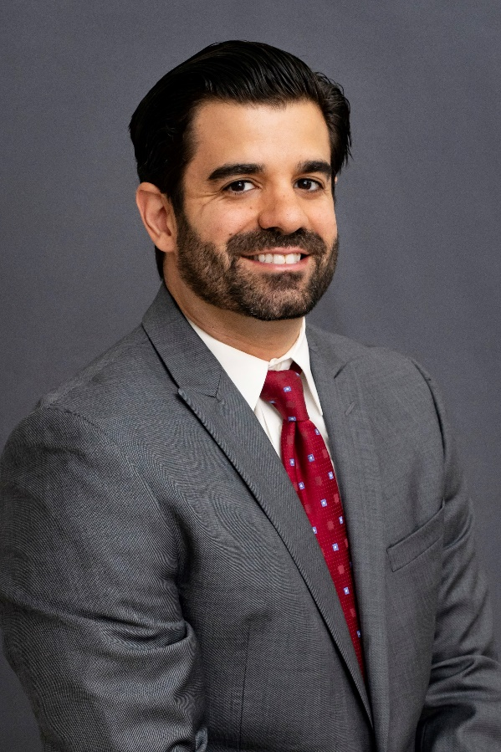
Justin Medeiros, Director of Accounting, Controller

ST. JOSEPH, Mich. – United Federal Credit Union (United) has appointed Justin Medeiros as Director of Accounting, Controller.

Medeiros brings 10 years of financial industry experience to United. Most recently he served as Vice President/Assistant Controller for BankNewport, based in Newport, Rhode Island.

In this position, Medeiros will lead United’s accounting team in the preparation and reporting of financial records. He will also serve as the in-house expert for the organization on all aspects of GAAP account and external financial reporting, and will be responsible for all accounting controls and policies.

Medeiros has a master of business of administration (MBA) and a bachelor of science degree in finance from Bryant University. He has earned several professional designations in accounting, including Certified Public Accountant (CPA) from the Rhode Island Board of Accountancy, and Chartered Property and Casualty Underwriter (CPCU) from the AICPCU Institute.

____________
About United
United Federal Credit Union has served its Members since 1949 by helping them to build a sound financial future. United consists of more than 180,000 Member/owners worldwide and manages assets in excess of $3.7 billion. Its corporate offices and main branch are in St. Joseph, Mich., with additional branches in Arkansas, Indiana, Michigan, Nevada, North Carolina, and Ohio. Federally insured by NCUA. Equal opportunity lender. Equal housing lender. For more information visit UnitedFCU.com

# # #

