

**United Federal Credit Union – Press Release**

July 12, 2021

Contact: Diana Wake

Phone: (888) 982-1400 ext. 6891

Email: [dwake@UnitedFCU.com](mailto:dwake@UnitedFCU.com)

United Federal Credit Union, 150 Hilltop Road, St. Joseph, Michigan, 49085

**United Names Angie Schwarz Director of Marketing**

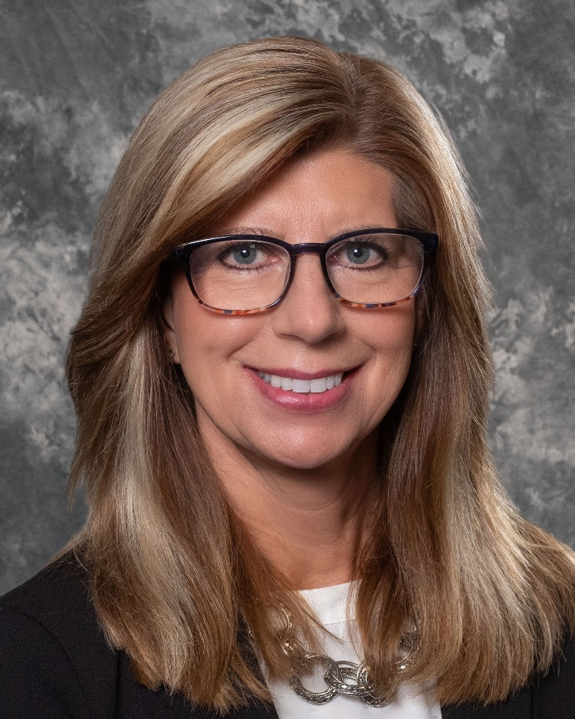

*Angie Schwarz, Director of Marketing*

**ST. JOSEPH, Mich.** – United Federal Credit Union (United) has appointed Angie Schwarz Director of Marketing based in St. Joseph, Michigan.

Schwarz brings more than 18 years of experience in marketing, advertising, and customer insights to United. Most recently she served as Chief Revenue Officer at Robert Weed, a wholesale distributor of building supplies in Bristol, Indiana.

In this position, Schwarz will lead United’s marketing, branding, events, donations and sponsorships by setting the marketing strategies and roadmaps for the credit union including digital marketing, product marketing, and content marketing. Schwarz will oversee all campaigns including promotions and line-of-business support to ensure all messages and creative executions are in-line with corporate identity and standards.

Schwarz has a bachelor of science degree from the school of engineering and possesses a minor in business from Western Michigan University. Her local volunteer and community work include being an active board member for the Boys & Girls Clubs of Benton Harbor as well as a previous board member for Habitat for Humanity of Elkhart County.

**____________**

**About United**

United Federal Credit Union has served its Members since 1949 by helping them to build a sound financial future. United consists of more than 180,000 Member/owners worldwide and manages assets in excess of $3.7 billion. Its corporate offices and main branch are in St. Joseph, Mich., with additional branches in Arkansas, Indiana, Michigan, Nevada, North Carolina, and Ohio. Federally insured by NCUA. Equal opportunity lender. Equal housing lender. For more information visit [UnitedFCU.com](http://www.unitedfcu.com)

# # #