

**United Federal Credit Union – Press Release**

June 8, 2021

Contact: Diana Wake

Phone: (888) 982-1400 ext. 6891

Email: [dwake@UnitedFCU.com](mailto:dwake@UnitedFCU.com)

United Federal Credit Union, 150 Hilltop Road, St. Joseph, Michigan, 49085

**United Federal Credit Union Sweepstakes Awards**

**$6,000 in Auto Loan Payments to Member**

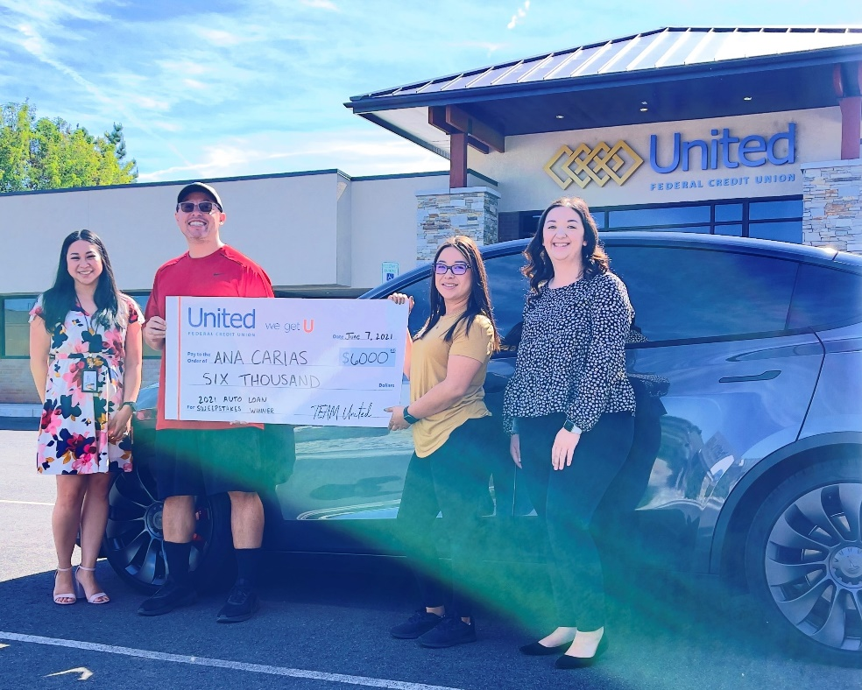

*Ana Carias presented with $6,000 after winning United’s Drive Away Happy Auto Loan Event*

**RENO, Nev.** – United Federal Credit Union (United) is excited to announce the winner of its “Drive Away Happy Auto Loan Event”. Ana Carias was randomly selected as the winner from the campaign that ran from the beginning of April through the end of May at United’s 41 branches nationwide.

Carias, a new United Member, received her auto loan from the Bible Way Branch in Reno, Nevada. As the winner of the sweepstakes, Carias will receive $6,000 to use for her auto loan payments.

“This is such a relief! I can’t believe this,” said Carias after she found out she won. “United has been awesome and has helped us out with everything with need.”

She was not the only winner in the sweepstakes. During the campaign, United approved more than 1,700 qualifying auto loans. With every approved loan, Members were given the choice of 90 days of no payments or $100 cash back.

“We are thrilled to be able to offer our Members perks like this sweepstakes along with great service and rates on all of our products,” said Meredith Williams, Market Vice President. “United makes banking easy and our Members know they are working with people who care about them and their future.”

United offers competitive low rates and flexible payment options on auto loans. Contact a local United branch or go to UnitedFCU.com to get preapproved.

**____________**

**About United**

United Federal Credit Union has served its Members since 1949 by helping them to build a sound financial future. United consists of more than 180,000 Member/owners worldwide and manages assets in excess of $3.6 billion. Its corporate offices and main branch are in St. Joseph, Mich., with additional branches in Arkansas, Indiana, Michigan, Nevada, North Carolina, and Ohio. Federally insured by NCUA. Equal opportunity lender. Equal housing lender. For more information visit [www.UnitedFCU.com](http://www.UnitedFCU.com)

# # #