

**United Federal Credit Union – Press Release**

July 26, 2021

Contact: Diana Wake

Phone: (888) 982-1400 ext. 6891

Email: [dwake@unitedfcu.com](mailto:dwake@unitedfcu.com)

United Federal Credit Union, 150 Hilltop Road, St. Joseph, Michigan, 49085

**United Federal Credit Union Names George Gerold**

**Mortgage Advisor in Reno, Nevada**

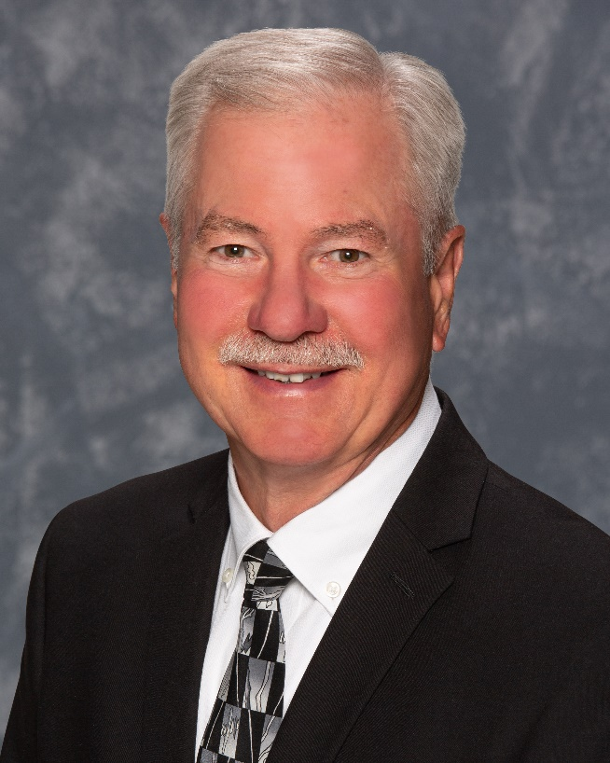

*George Gerold, Mortgage Advisor, Summit Branch*

**RENO, Nev.** – United Federal Credit Union (United) is pleased to announce the appointment of George Gerold as Mortgage Advisor at its Summit Branch at 13989 South Virginia Street in Reno.

Gerold will provide quality real estate lending expertise through financial counseling and product awareness to credit union members regarding their real estate financing needs and generate investment quality mortgage loans.

Gerold brings more than 36 years of mortgage and financial experience to his new role. Most recently, he was the branch manager for Celebrity Home Loans, LLC in Reno. He pairs his industry knowledge with a passion to help people find the right mortgage option for their new home.

Gerold lives the credit union philosophy of ‘people helping people’ not only through member service, but also community involvement. He is looking forward to working with United’s community partners in northwest Nevada including United Way of Northern Nevada and the Sierra and the Boys and Girls Club of Truckee Meadows.

**____________**

**About United**

United Federal Credit Union has served its Members since 1949 by helping them to build a sound financial future. United consists of more than 180,000 Member/owners worldwide and manages assets in excess of $3.7 billion. Its corporate offices and main branch are in St. Joseph, Mich., with additional branches in Arkansas, Indiana, Michigan, Nevada, North Carolina, and Ohio. Federally insured by NCUA. Equal opportunity lender. Equal housing lender. For more information visit [www.unitedfcu.com](http://www.unitedfcu.com)

# # #