United Federal Credit Union – Press Release
June 25, 2021

Contact: Diana Wake
Phone: (888) 982-1400 ext. 6891
Email: dwake@UnitedFCU.com
United Federal Credit Union, 150 Hilltop Road, St. Joseph, Michigan, 49085

United Federal Credit Union Welcomes
New Board Director and Associate Director

ST. JOSEPH, Mich. – United Federal Credit Union (United) is pleased to announce the appointment of two new members to its Board of Directors — Jim Marohn, board director, and Deanna Wiedner, associate director. Marohn and Wiedner will help the credit union achieve its mission of improving members’ lives, enhancing local communities, and building a strong organization for years to come.

“Jim and Deanna will bring proven leadership and invaluable insights to our board room,” said United President/CEO Terry O’Rourke. “We are excited to welcome them to the Board and look forward to their contributions to United’s continued growth.
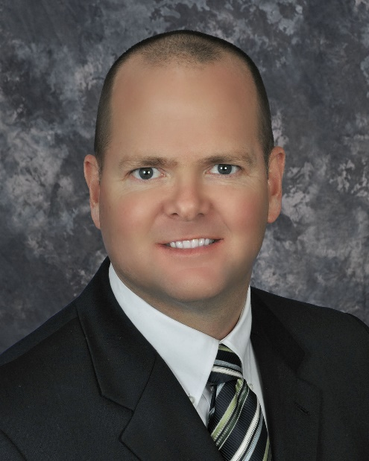
Jim Marohn, Board Director

Jim Marohn is president and principal owner of Doubleday Office Products Inc in Benton Harbor, Michigan. He previously served on Edgewater Bank’s Board of Directors.

In the southwest Michigan community, Marohn is passionate about veterans’ services and helps organize the Trolling with the Troops free fishing outing for local military veterans. He has also previously served as a Board Member at Large for the St. Joseph-Benton Harbor Rotary Club, and currently serves as Co-VP of Fund Development with the St. Joseph Public Schools Foundation.

Marohn is a graduate of the University of Michigan with a Bachelor of Engineering Degree, and Duke University’s Fuqua School of Business.

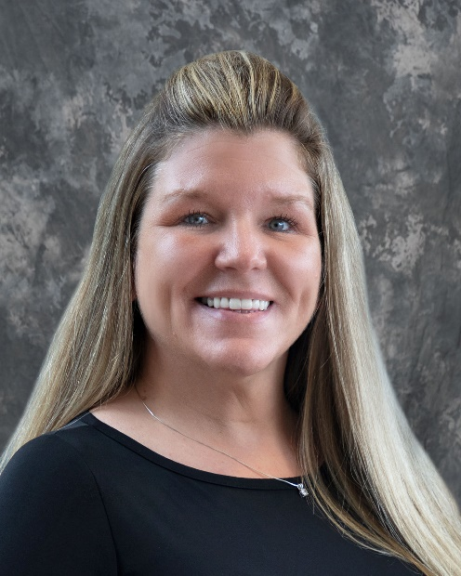
Deanna Wiedner, Associate Director

Deanna Wiedner has more than 11 years’ experience in human resources. Currently she is vice president HR for Business Services at Tyson Foods, Inc., headquartered in Springdale, Arkansas and has been with the company since 1991.

Her accomplishments in human resources—including using data and analytics to drive ‘people’ initiatives, and championing change through new processes, technologies, workflows and organizational structures—will bring valuable insights to United’s board room. In the community, Wiedner is a proud supporter of CASA of Northwest Arkansas.

She is pursuing her bachelor’s degree in science business with an emphasis in human resources management from Excelsior College.

____________
About United
United Federal Credit Union has served its Members since 1949 by helping them to build a sound financial future. United consists of more than 180,000 Member/owners worldwide and manages assets in excess of $3.7 billion. Its corporate offices and main branch are in St. Joseph, Mich., with additional branches in Arkansas, Indiana, Michigan, Nevada, North Carolina, and Ohio. Federally insured by NCUA. Equal opportunity lender. Equal housing lender. For more information visit UnitedFCU.com

# # #

