United Federal Credit Union – Press Release
June 16, 2021

Contact: Diana Wake
Phone: (888) 982-1400 ext. 6891
Email: dwake@UnitedFCU.com
United Federal Credit Union, 150 Hilltop Road, St. Joseph, Michigan, 49085

United Federal Credit Union Names Paul Rodriguez
Branch Manager at Carson City South Location
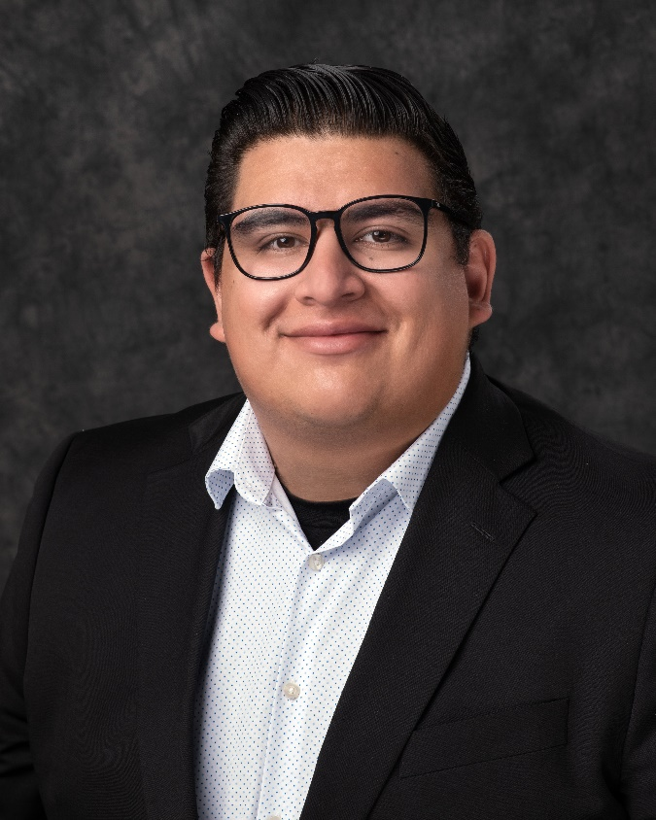
Paul Rodriguez, Branch Manager, Carson City South Branch

CARSON CITY, Nev. – United Federal Credit Union (United) has named Paul Rodriguez to the position of Branch Manager at its Carson City South branch at 935 Jacks Valley Road.

As Branch Manager, Rodriguez will be responsible for maintaining the performance of the branch, and providing leadership and supervision to staff.

He brings nearly eight years of financial and banking experience to his new role. Most recently, Rodriquez served as Branch Manager at the Wells Fargo in South Lake Tahoe.

Rodriguez is looking forward to supporting United’s community involvement in the Carson City area with organizations including the Boys and Girls Club of Western Nevada and the American Red Cross Northern Nevada chapter.
____________
About United
United Federal Credit Union has served its Members since 1949 by helping them to build a sound financial future. United consists of more than 180,000 Member/owners worldwide and manages assets in excess of $3.6 billion. Its corporate offices and main branch are in St. Joseph, Mich., with additional branches in Arkansas, Indiana, Michigan, Nevada, North Carolina, and Ohio. Federally insured by NCUA. Equal opportunity lender. Equal housing lender. For more information visit www.UnitedFCU.com

# # #

