FOR IMMEDIATE RELEASE

Media Contact:
Elizabeth Marshall
734.662.8200
media@umcu.org

UNIVERSITY OF MICHIGAN CREDIT UNION DONATES $5,000 TO THE MICHIGAN FOSTER CARE CLOSET WITH HELP OF LOCAL BUSINESSES AND COMMUNITY

ANN ARBOR, Mich. (February 4, 2021) – Local foster children and their families will be able to make birthday celebrations extra special thanks to a recent donation of $5,000 to the Michigan Foster Care Closet (MFCC) from the University of Michigan Credit Union (UMCU). This gift was made possible with the help of 83 local businesses during UMCU’s “Shop Local Give Local” campaign.

Throughout November and December, UMCU matched and donated one percent of the total sales to MFCC when members made purchases with their UMCU Visa® credit cards at participating stores, restaurants, cafes, and more. As a philanthropic credit union dedicated to the local community, the purpose of this campaign was to help make a positive difference for an impactful charitable organization while strengthening the relationship between UMCU members and locally-owned businesses in the Ann Arbor, Ypsilanti, Saline, Flint and Dearborn communities.

According to MFCC, the donation will go towards creating a Birthday Box program. This program will provide each foster child with a “Birthday Party in a Box.” Each box will include three to four birthday gifts, a cake, frosting, party supplies, decorations and more.

“The incredible partnership between the Michigan Foster Care Closet, University of Michigan Credit Union, and over 80 locally-owned businesses means that, together, we are helping to clothe children in confidence and self-esteem. When a community comes together to support its most vulnerable people, it is then that their true strength shines through. We are all better together,” said Jennie Sharp, Michigan Foster Care Closet Board Treasurer and Director of Ann Arbor Branch.

-more-

Due to the unprecedented impact of the coronavirus (COVID-19) pandemic on local businesses, strengthening the message of “Shop Local Give Local,” and demonstrating the importance of shopping and dining locally at small businesses was imperative. Through partnerships with local chambers of commerce and non-profit organizations, UMCU added several new local restaurants and retailers to its list of participating vendors.

“UMCU’s Shop Local Give Local, and programs like it, benefit the whole community. Not only is the effort working in conjunction with important charities like Michigan Foster Care Closet, but it brings together consumers and small businesses, keeping dollars spent locally and benefitting the economy of the local community,” said Amber Wardia, owner of Enchanted Oven.

Local businesses that helped make this donation possible include Spun, Ann Arbor Running Company, Underground Printing, The Bo Store, Thrive Juicery, The Chop House, Real Seafood Company, Palio, Carson’s American Bistro, Roeda Studio, Found Gallery, Parrish Framing, Catching Fireflies, Frita Batidos, Le Bon Macaron, RoosRoast Coffee, Nicola’s Books, University Flower Shop, Bivouac, Imagine Three Beauty Studio, Priceless Preservation, Seva Restaurant, The Lunch Room Bakery & Café, Detroit Street Filling Station, Vault of Midnight, Oz’s Music, Lewis Jewelers, Jerusalem Garden, Thistle & Bess, The Grotto Watering Hole, Regents Field, Cherry Republic, Dixboro General Store, Downtown Home and Garden, Dbts Skin Bar LLC, B Young B Fit LLC, Black Diesel Coffee, Crazy Wisdom Bookstore, Collected Works, SpaLyfe Ann Arbor, Real Irish, Underground Sounds, Abracadabra Jewelry, Apples & Oranges, The M Den, Carlyle Grill, 16 Hands, Mudpuddles Toys, Sweetwaters Coffee & Tea, Ten Thousand Villages, The Earle Restaurant, Decode Ann Arbor, Blom Meadworks, Cobblestone Rose, McPherson Local, Carrigan Café, Enchanted Oven, Cheese Shop of Saline, Black Stone Book Store, Ypsilanti Running Company, OJ’s Beauty Supply, 24th Cheesecakerie, MAIZ Mexican Cantina, The Rocket, Sidetrack Bar and Grill, Go Ice Cream, Decode Ypsilanti, Latina Restaurant and Pizzeria, Complete Runner, Fireside Coffee Company, Flint Coffee Company, SHIFT, Shumaker’s Ski and Snowboard, Rocky’s Great Outdoors, Detroit Book City, Dearborn Music, and Brome Modern Eatery.

“Programs like Shop Local Give Local bring attention to small businesses while helping to support those who live in that neighborhood and are affected by the businesses’ prosperity. In many ways, the effects of shopping small and supporting charities are the same, they are seeds that grow and produce something beautiful that people from all walks of life can appreciate,” said Carlos Franklin, owner of Black Stone Bookstore & Cultural Center.

“Being a part of UMCU’s Shop Local Give Local campaign is nice because we get to connect with different local businesses that we might not otherwise get to connect with. Having the support of UMCU and other like-minded businesses goes a long way because these community networks help to spread the good word about the work everyone is doing,” said Nick Stanko, owner of Ann Arbor Running Company.
-more-

This was the fifth year UMCU raised funds for a local charity through “Shop Local Give Local.” Last year, this campaign helped 20 local students take advantage of a 6-week summer program at the Community Action Network designed to prepare under-resourced teens for their potential career goals by developing soft and employability skills, as well as providing the opportunity to explore a few different career paths, networking and beginning to chart a path towards personal goals.

“At UMCU, we’re all about people helping people, and this year in particular, we knew it was imperative to encourage our members to shop at these local businesses. Through ‘Shop Local Give Local, we grow stronger relationships between the local charities, local businesses, and UMCU members because everyone is working towards the common goal of making a positive impact in our community. It’s truly a win-win-win, and hits at the heart of who we are at the credit union – helping people. We are incredibly grateful to everyone who supported the campaign and made this incredible donation to MFCC possible,” said Julie Wigley, UMCU Vice President of Brand and Community Development.

In recognition of its fifth annual Shop Local Give Local promotion, five local participating businesses were randomly chosen to win $500 each, and in addition to contributing to the donation, every time members used their UMCU Visa credit cards at the partner vendors during the promotional period, they were entered for the chance to be one of five lucky members to win $1,000. Ann Arbor Running Company, Black Stone Bookstore and Cultural Center, Enchanted Oven, Shumaker Snowboard and Ski, and Detroit Book City were the local businesses randomly selected as raffle winners.

“As a small business owner, many of us have felt the weight of the world on our shoulders this past year, and just to know we are appreciated is the best feeling” said Wardia.

Michigan Foster Care Closet is a non-profit organization that provides basic essentials for foster children and families, including clothes, hygiene products, school supplies and so much more. For more information, visit: https://www.michiganfostercarecloset.org

About the University of Michigan Credit Union
The University of Michigan Credit Union is a member-owned, not-for-profit cooperative. Its purpose is to amaze UMCU members, the community, and its team by working together for shared success.

UMCU is the only credit union headquartered in Ann Arbor, Michigan. When established in 1954, there were 12 members and $9 in assets. Today, UMCU has more than 100,000 members and more than $1 billion in assets, and it continues to grow. With eight branches in Ann Arbor, one in Ypsilanti, a branch in Dearborn, and three branches in Flint, UMCU serves the financial needs of the University of Michigan, Eastern Michigan University, Washtenaw Community College, and their surrounding communities. For more information, visit umcu.org or follow UMCU on Facebook, LinkedIn, Twitter, and Instagram.
-more-

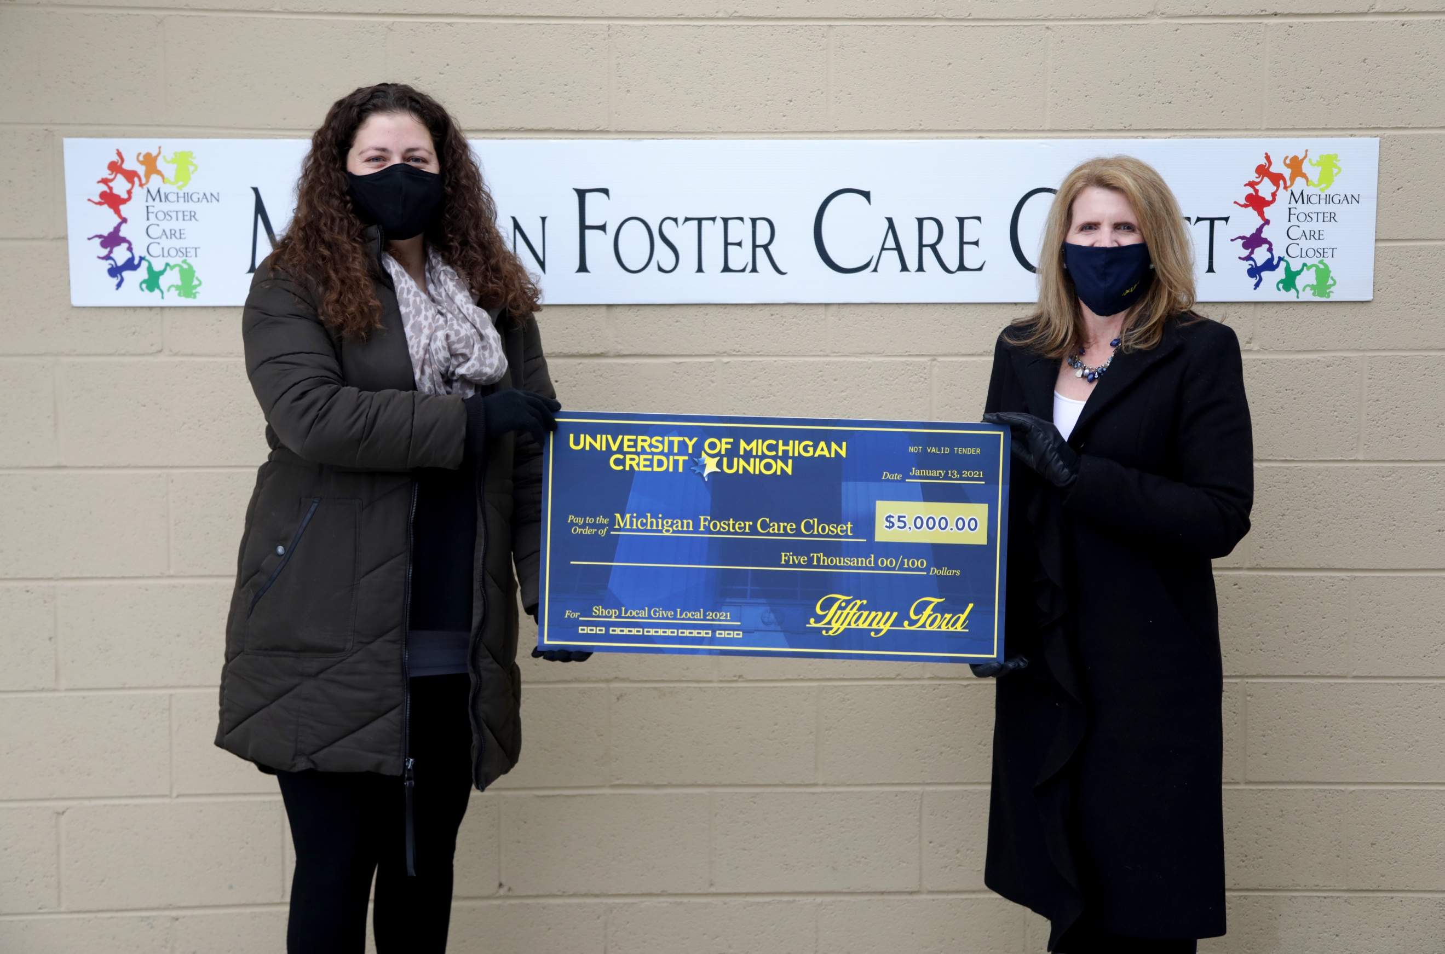

R: UMCU Vice President of Brand and Community Development, Julie Wigley, presenting the donation to MFCC, at the Michigan Foster Care Closet Ann Arbor in Ann Arbor, Michigan.

-end-

