Craig A. Boivin
Vice President of Marketing
413-256-5553 | cboivin@umassfive.coop

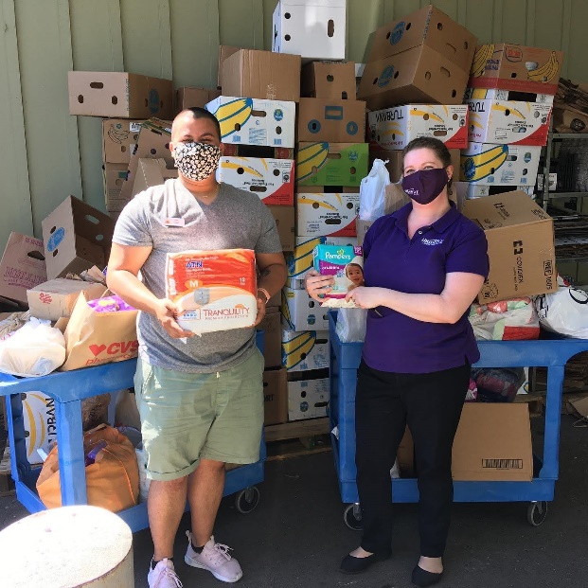
UMassFive Donates 350 Pounds of Personal Care Items to Local Survival Centers
L-R: Sez Morales, Amherst Survival Center Pantry Coordinator and Cait Murray, UMassFive Community Outreach Manager with personal care item donations
Hadley, MA – UMassFive College Federal Credit Union (UMassFive) collected and donated 350 pounds of personal care items to the pantries of the Amherst and Northampton Survival Centers during the month of May.
Donations were collected at the Hadley and Northampton Branch locations, and included incontinence products, toilet paper, diapers, menstrual products, soap, shampoo, conditioner, deodorant, sunblock, and many other personal care items.
“We’re so appreciative of our members and employees for donating personal care items to our annual drive,” said Cait Murray, Community Outreach Manager at UMassFive. “We know that personal care items in the Survival Center pantries may help people avoid making difficult trade-offs. Nobody should have to choose between food and toilet paper.”
For more information regarding the Amherst Survival Center, please visit www.amherstsurvival.org and for Northampton Survival Center, www.northamptonsurvival.org.

UMassFive College Federal Credit Union (UMassFive) was established in 1967 and serves the University of Massachusetts, as well as the Five College System and over 50 other local organizations that share their community-based values and vision for a sustainable local economy. As a non-profit financial cooperative, UMassFive’s earnings are returned to their membership in the form of better rates, lower fees, and improved services and banking technology. The Credit Union offers a full range of financial products, including personal and business banking and lending, retirement planning and investments, and insurance. UMassFive has over 42,000 members, six branches, and assets of over $600 million. For more information about UMassFive, please visit www.umassfive.coop.

