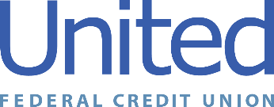

United Federal Credit Union – Press Release
August 26, 2021

Contact: Diana Wake
Phone: (888) 982-1400 ext. 6891
Email: dwake@UnitedFCU.com
United Federal Credit Union, 150 Hilltop Road, St. Joseph, Michigan, 49085

United Federal Credit Union Names Amy Geideman
Branch Manager at Niles North Branch
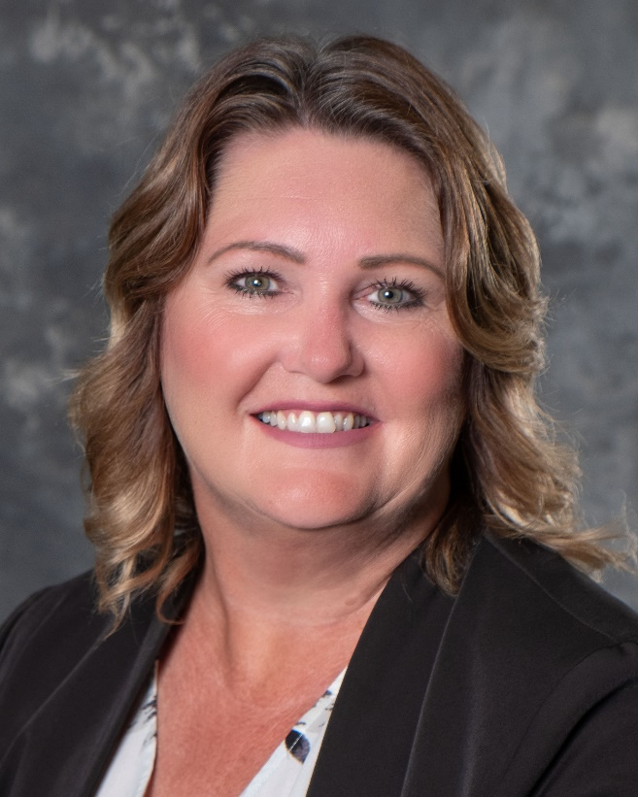
Amy Geideman, Branch Manager, Niles North Branch

NILES, Mich. – United Federal Credit Union (United) has named Amy Geideman to the position of Branch Manager at its Niles North branch at 123 Sycamore Street in Niles.

As Branch Manager, Geideman will be responsible for maintaining the performance of the branch, and providing leadership and supervision to staff.

Geideman brings more than 32 years of financial experience in southwest Michigan to her new role. Prior to becoming branch manager, she was most recently Vice President Branch Manager at Chase Bank in Benton Harbor.

Geideman is active in the community. She is currently president of the Southwest Michigan Scholarship Program. She also looks forward to supporting United’s community impact efforts with organizations such as the United Way of Southwest Michigan, and other local non-profit groups.

____________
About United
United Federal Credit Union has served its Members since 1949 by helping them to build a sound financial future. United consists of more than 180,000 Member/owners worldwide and manages assets in excess of $3.7 billion. Its corporate offices and main branch are in St. Joseph, Mich., with additional branches in Arkansas, Indiana, Michigan, Nevada, North Carolina, and Ohio. Federally insured by NCUA. Equal opportunity lender. Equal housing lender. For more information visit UnitedFCU.com

# # #

