United Federal Credit Union – Press Release
April 23, 2021

Contact: Diana Wake
Phone: (888) 982-1400 ext. 6891
Email: dwake@unitedfcu.com
United Federal Credit Union, 150 Hilltop Road, St. Joseph, Michigan, 49085

United Federal Credit Union and American Red Cross
Blood Drive Yields Donations to Save 81 Lives

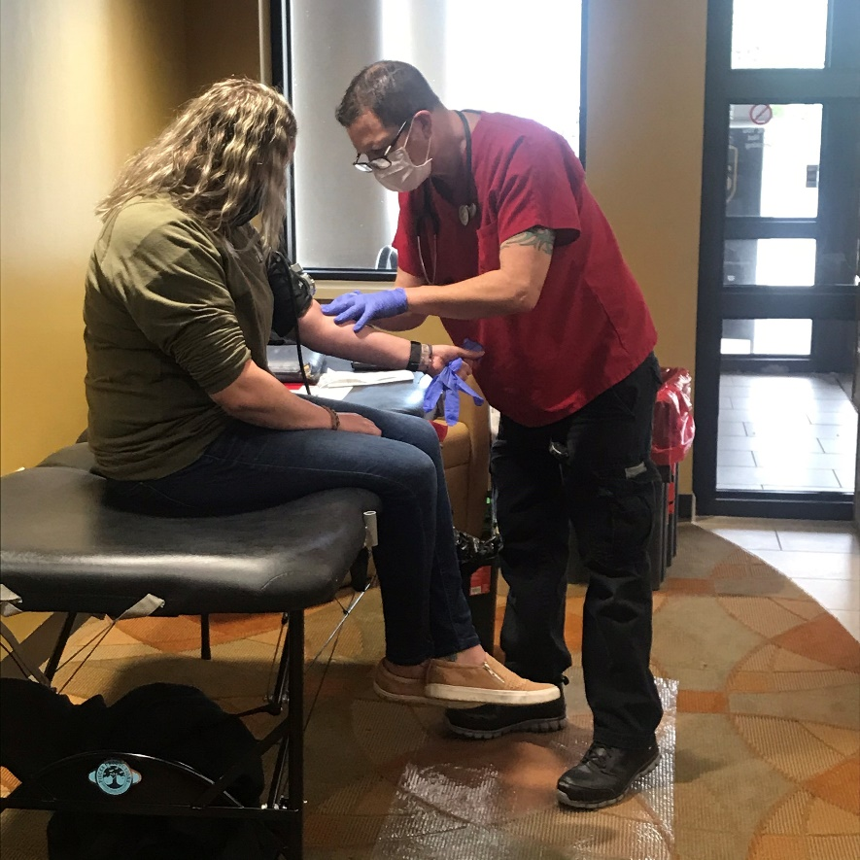
A person donates blood during an American Red Cross Blood Drive
hosted by United Federal Credit Union in St. Joseph, MI

ST. JOSEPH, Mich. – More than a year into the COVID-19 pandemic, there is an ongoing critical need for blood donations. That is why United Federal Credit Union was pleased to partner with the American Red Cross to host a blood drive on April 20 at its former headquarters at 2807 S. State Street in St. Joseph, Michigan. Through the generosity of individuals from the community, enough blood was donated to potentially save 81 lives.
“We are so proud of the way Team United, our Members, and the community stepped up to donate blood in this time of need,” said Kimetha Firpo, United’s Senior Vice President of Human Resources. “This event shows the positive impact that can be made in our community by living the credit union philosophy of ‘people helping people.’ This is why we partner with phenomenal organizations like the American Red Cross; it really takes all of us working together to do our part in improving the lives of others.”

The American Red Cross said the need for blood, especially during the pandemic, is constant. With COVID-19 causing schools, universities and businesses to cancel blood drives, the importance of finding alternate locations and hosts for blood drives is crucial.

“There is no substitute for blood, which is why it is imperative for companies like United to host blood drives,” said JP Lanning, Red Cross Donor Representative for southwest Michigan. “Having a partner like United means so much to the Red Cross. United is always giving back to the community and people recognize that commitment.”

Every two seconds someone in the United States needs blood, according to the American Red Cross. Donations from blood drives help patients of all ages: accident and burn victims, heart surgery and organ transplant patients, and those battling cancer.

____________
About United
United Federal Credit Union has served its Members since 1949 by helping them to build a sound financial future. United consists of more than 179,000 Member/owners worldwide and manages assets in excess of $3.3 billion. Its corporate offices and main branch are in St. Joseph, Mich., with additional branches in Arkansas, Indiana, Michigan, Nevada, North Carolina, and Ohio. Federally insured by NCUA. Equal opportunity lender. Equal housing lender. For more information visit www.unitedfcu.com

# # #

