United Federal Credit Union – Press Release
March 17, 2022

Contact: Diana Wake
Phone: (888) 982-1400 ext. 6891
Email: dwake@UnitedFCU.com
United Federal Credit Union, 150 Hilltop Road, St. Joseph, Michigan, 49085

United Federal Credit Union Names Brian Jones
Commercial Loan Officer in Hendersonville, North Carolina
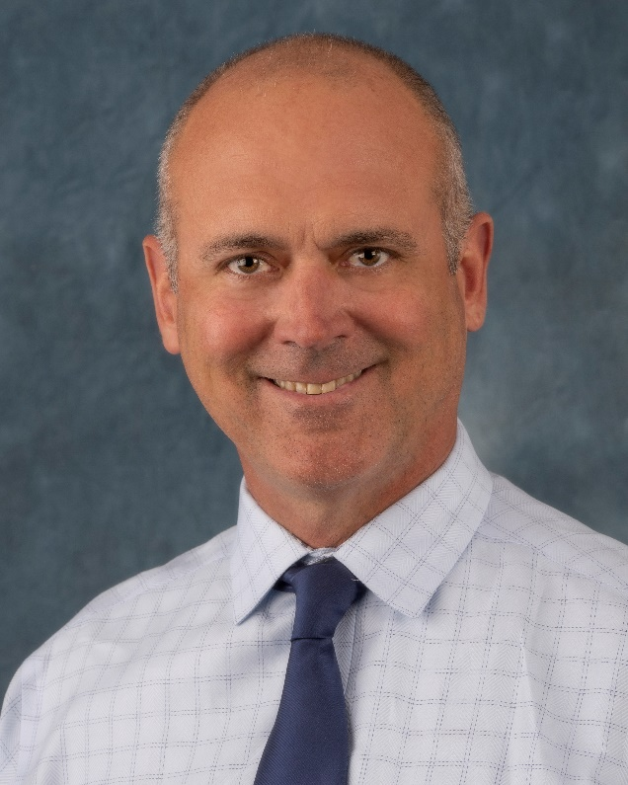
Brian Jones, Commercial Loan Officer, Hendersonville

HENDERSONVILLE, North Carolina – United Federal Credit Union (United) has appointed Brian Jones as Commercial Loan Officer at its branch in Hendersonville, North Carolina.
As the Commercial Loan Officer, Jones is responsible for providing quality business lending expertise through financial counseling and product awareness to Credit Union members regarding their business financing needs and generates investment quality business loans by taking loan applications in support of loan growth objectives.

Jones brings more than 18 years of financial industry experience to his new role. He has worked in the Hendersonville area since 2007. Most recently, he was Branch Manager/Loan Officer for First Citizens Bank/Entegra Bank.

Jones graduated from Winthrop University with a bachelor of science degree. He also attended The North Carolina School of Banking, UNC Chapel Hill.
____________
About United
United Federal Credit Union has served its Members since 1949 by helping them to build a sound financial future. United consists of more than 191,000 Member/owners worldwide and manages assets in excess of $3.8 billion. Its corporate office and main branch are in St. Joseph, Mich., with additional branches in Arkansas, Indiana, Michigan, Nevada, North Carolina, and Ohio. Federally insured by NCUA. Equal opportunity lender. Equal housing lender. For more information visit UnitedFCU.com

# # #

