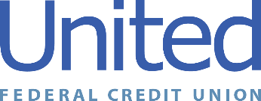

**United Federal Credit Union – Press Release**

November 1, 2021

Contact: Diana Wake

Phone: (888) 982-1400 ext. 6891

Email: [dwake@UnitedFCU.com](mailto:dwake@UnitedFCU.com)

United Federal Credit Union, 150 Hilltop Road, St. Joseph, Michigan, 49085

**United Federal Credit Union Leader Named One of the Most Influential Women of the Sierra Nevada**

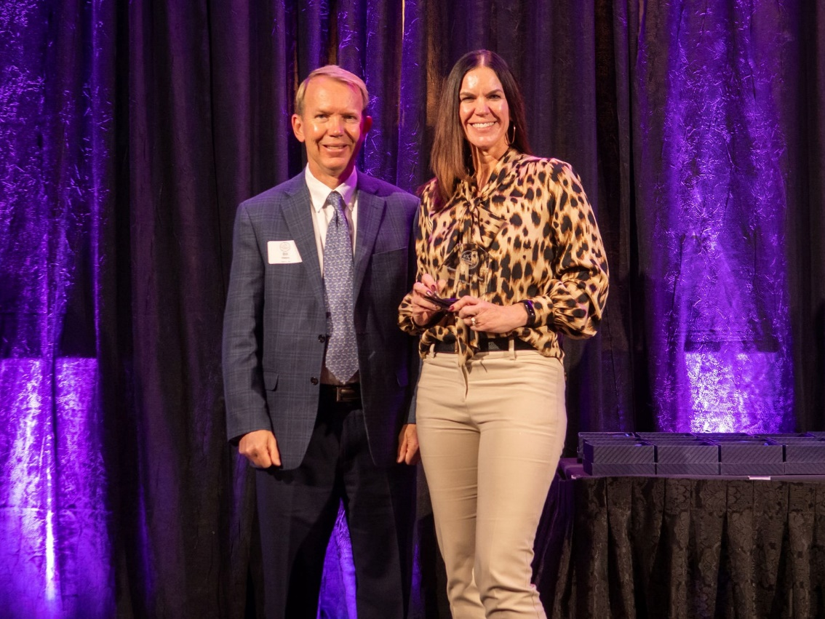

*Meredith Williams (right) selected as one of the*

*Most Influential Women of the Sierra Nevada*

**RENO, Nev. –** United Federal Credit Union (United) is pleased to announce its Market Vice President in Nevada has been named one of the 10 Most Influential Women of the Sierra Nevada in 2021. Meredith Williams was selected for the honor by Influential Women of the Sierra Nevada at an event on October 27.

“It means the world to me to achieve this recognition as a leader in our community, to my team, my family, and my daughter specifically whom I try to be a positive female role model to,” said Williams. “When I heard my name announced I was genuinely surprised and not sure what to do! My team told me if I won I had to do a dance, so I turned to them and did a dance.”

This is the fourth year Influential Women of the Sierra Nevada has brought together leaders from around the Reno area to celebrate the contributions women make in the community. Nominees are submitted to the organization, and once the final 40 have been selected, public votes and the recommendation of the organization’s Board of Advisors determined the 10 winners.

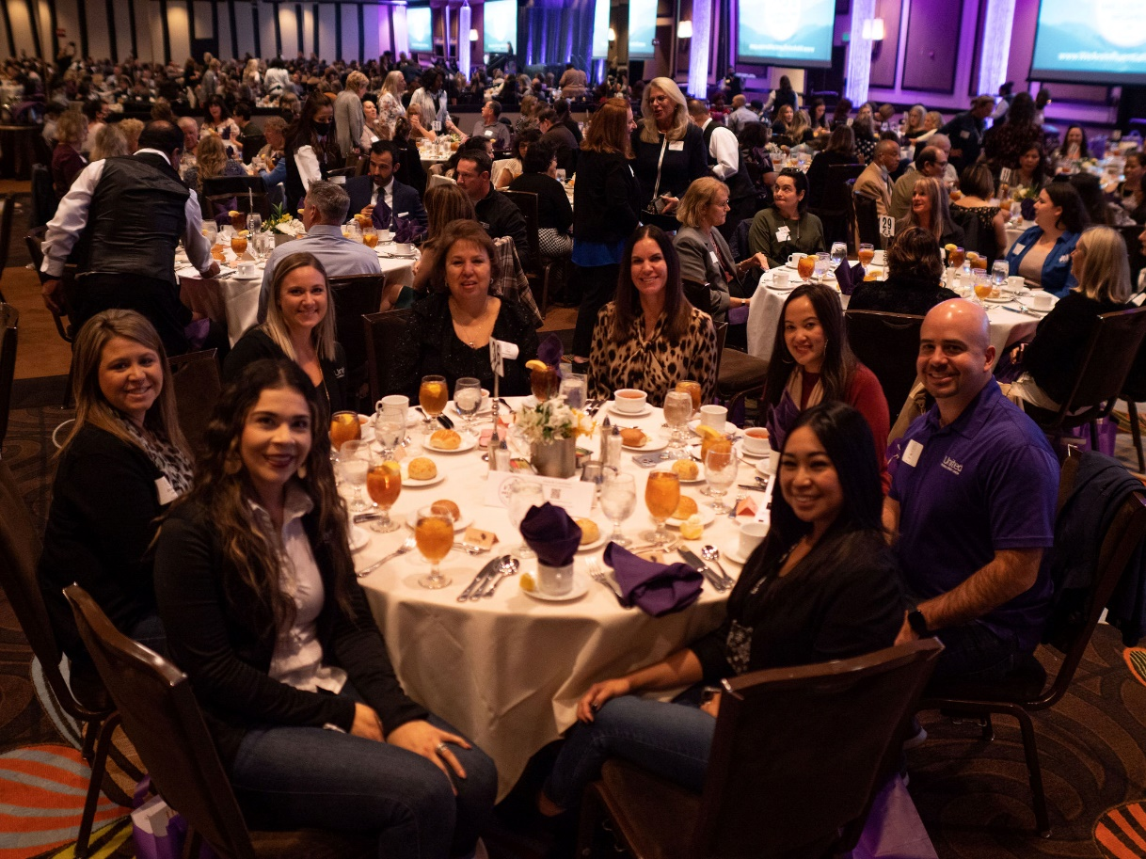

*Meredith Williams (center right) poses with her United Federal Credit Union team*

“Meredith loves our community and continues to shine by giving back,” said Jeff Panko, Regional Market Development Manager. “She gives her all in everything she does, from being involved in multiple non-profits to spending time with each of us on her management team developing and encouraging us to be the best we can be. It’s not a surprise to us that she was named one of the Most Influential Women of the Sierra Nevada!”

Williams has been United’s Market Vice President in Nevada since 2018. She is extremely involved in the Reno community—serving on the boards of Big Brothers Big Sisters, the Reno Sparks Chamber of Commerce, and Justin Hope Foundation.

**____________**

**About United**

United Federal Credit Union has served its Members since 1949 by helping them to build a sound financial future. United consists of more than 180,000 Member/owners worldwide and manages assets in excess of $3.7 billion. Its corporate offices and main branch are in St. Joseph, Mich., with additional branches in Arkansas, Indiana, Michigan, Nevada, North Carolina, and Ohio. Federally insured by NCUA. Equal opportunity lender. Equal housing lender. For more information visit [UnitedFCU.com](http://www.unitedfcu.com)

# # #