United Federal Credit Union – Press Release
September 10, 2021

Contact: Diana Wake
Phone: (888) 982-1400 ext. 6891
Email: dwake@UnitedFCU.com
United Federal Credit Union, 150 Hilltop Road, St. Joseph, Michigan, 49085

United Federal Credit Union Announces Winner
of Best. Week. Ever. Tiny House Sweepstakes

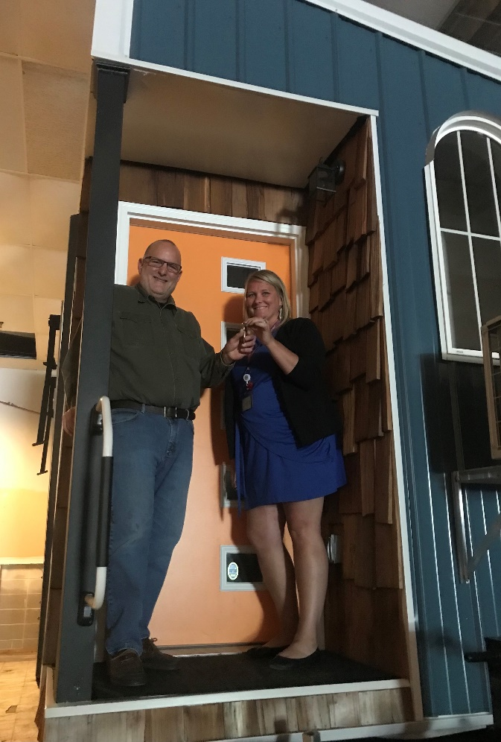
Blake Vedder receives keys after being selected as Tiny House winner

SOUTH BEND, Ind. – United Federal Credit Union (United) is pleased to announce the winner of its Best. Week. Ever. Tiny House Sweepstakes. Blake Vedder of South Bend was randomly selected as the winner.

“It is still hard to believe I won the tiny house,” said Vedder. “My wife and I went to Brunch on the Bend on the last day of Best. Week. Ever. We saw the tiny house as we were leaving and thought we might as well enter. When I got the call I had won, I actually joked with my wife that it was probably United calling to say I had won before I picked up. I was pretty shocked and in a haze for about a week after finding out because I couldn’t believe it! We are very appreciative of everyone at United. They’ve all been great to work with!”

Vedder owns a cabin in Michigan and plans to park the tiny house on the property and use it as an extra room for family and guests.

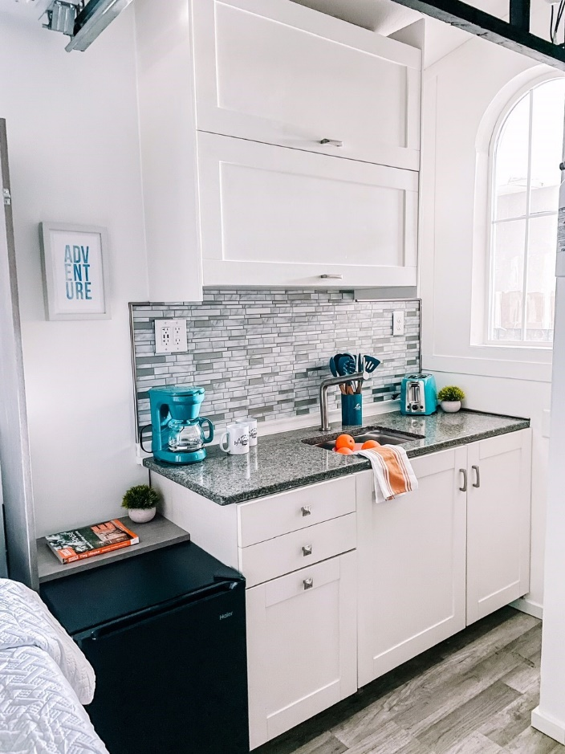
The kitchen space in the Tiny House

“We were so excited to be the presenting sponsor for Best. Week. Ever. for the fifth year and to be able to give away the tiny house,” said Carla Fazio-King, United’s Regional Market Development Manager for South Bend. “After having to cancel the event last year, it was fantastic to be able to see everyone come out and support the South Bend community this summer. United is proud to be part of such a wonderful event that highlights all the great things South Bend has to offer.”

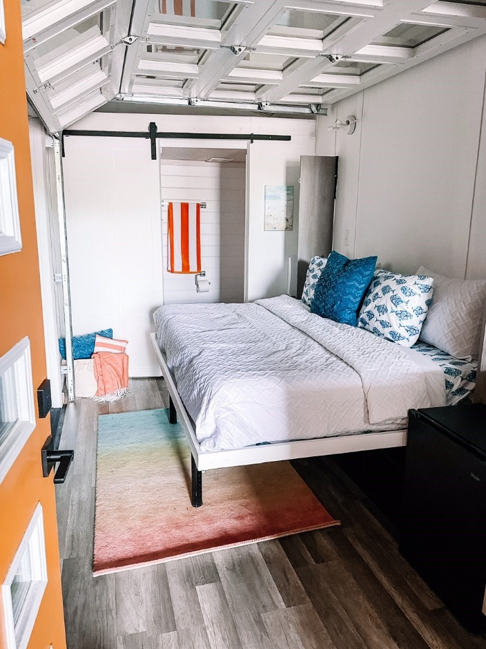
The lounge space in the Tiny House

The tiny house is a mobile unit which traveled around to various locations during Best. Week. Ever. the week of August 1 through August 7, 2021. When people visited the display, they were able to not only see the tiny house, but also enter the sweepstakes to win it.

The mobile unit was built by Voodoo Dream Work located in Mishawaka, Indiana. The tiny house was designed to be a self-contained unit plumbed for waste and water, and to include designated areas for a kitchen, bathroom, living space, and sleeping area. It also features a drop-down patio for indoor/outdoor living. The home is approximately 14’ tall x 8’ wide x 28’ long and weighs nearly 8,300 pounds.

____________
About United
United Federal Credit Union has served its Members since 1949 by helping them to build a sound financial future. United consists of more than 180,000 Member/owners worldwide and manages assets in excess of $3.7 billion. Its corporate offices and main branch are in St. Joseph, Mich., with additional branches in Arkansas, Indiana, Michigan, Nevada, North Carolina, and Ohio. Federally insured by NCUA. Equal opportunity lender. Equal housing lender. For more information visit UnitedFCU.com

# # #

