United Federal Credit Union – Press Release
July 8, 2021

Contact: Diana Wake
Phone: (888) 982-1400 ext. 6891
Email: dwake@UnitedFCU.com
United Federal Credit Union, 150 Hilltop Road, St. Joseph, Michigan, 49085

United Federal Credit Union Donates $10,000
to Unified Civic Monuments Project
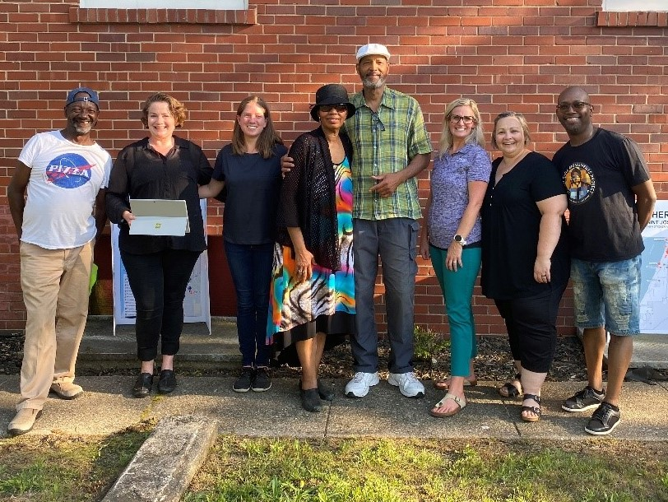
Team United Members after presenting a donation
to Unified Civic Monuments Project

ST. JOSEPH, Mich. – United Federal Credit Union (United) is proud to support the Unified Civil Monuments Project by donating $10,000 to the community initiative. The funds will be used to help build four monuments in the cities of Benton Harbor and St. Joseph, Michigan by 2022.

“The seed money we receive from organizations like United is important to help us reach more companies and individuals, as well as to bolster our grant applications as we begin this project,” said Mike Nadolski, Executive Director of the Mendel Center at Lake Michigan College and fundraising lead for the Unified Civic Monuments Project. “We are incredibly grateful to United for their generous donation and for recognizing the potential in this project to heal old wounds and raise expectations for us all.”

The Unified Civil Monuments Project plans to erect public monuments in Berrien County to honor the influence and strength of Dr. Martin Luther King Jr. The project needs to raise $850,000 in order to build two complementary monuments in Benton Harbor and St. Joseph to represent Dr. King and two additional monuments to honor another historic figure in each city, yet to be determined.

“We are grateful to have the opportunity to support the Unified Civil Monuments Project’s mission of helping to ‘remind our community of the value of humanity’,” said Jodie Kitchell, United’s Regional Market Development Manager. “United is committed to improving the communities where we work and live, and these statues will become an important part of the cities of Benton Harbor andSt. Joseph for years to come.”

The project is led by the founders of the African American History & Literature Gallery, with the support of Krasl Art Center, Lake Michigan College, the BH/SJ Arts & Culture Social Justice Group, and the cities of Benton Harbor and St. Joseph.
____________
About United
United Federal Credit Union has served its Members since 1949 by helping them to build a sound financial future. United consists of more than 180,000 Member/owners worldwide and manages assets in excess of $3.7 billion. Its corporate offices and main branch are in St. Joseph, Mich., with additional branches in Arkansas, Indiana, Michigan, Nevada, North Carolina, and Ohio. Federally insured by NCUA. Equal opportunity lender. Equal housing lender. For more information visit UnitedFCU.com

____________
About Unified Civic Monuments Project
This project is led by the founders of the African American History & Literature Gallery, with the support of Krasl Art Center, Lake Michigan College, Southwest Michigan Symphony Orchestra, the BH/SJ Arts & Culture Social Justice Group, and the cities of Benton Harbor and St. Joseph. Information can be found at unifiedmonuments.org.

# # #

