United Federal Credit Union – Press Release
September 15, 2021

Contact: Diana Wake
Phone: (888) 982-1400 ext. 6891
Email: dwake@UnitedFCU.com
United Federal Credit Union, 150 Hilltop Road, St. Joseph, Michigan, 49085

United Federal Credit Union Sponsors Inaugural
United Rosie Games in South Bend
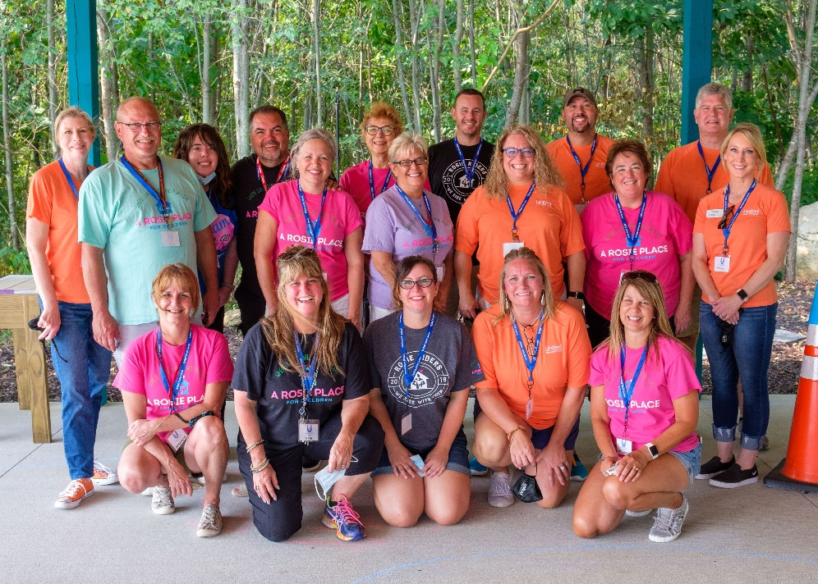
Volunteers gather for Inaugural United Rosie Games

SOUTH BEND, Ind. – United Federal Credit Union (United) was proud to sponsor the inaugural “United Rosie Games” with A Rosie Place for Children. The event took place on Saturday, September 11, 2021, and was the first competition of its kind for medically fragile children in Indiana.

“It was such an honor to be the sponsor of the inaugural United Rosie Games,” said Carla Fazio-King, United’s Regional Market Development Manager. “The credit union philosophy is ‘people helping people’, but on Saturday, that took on a whole new meaning for Team United members at the event. The children participating in the games were so excited, and we couldn’t have been happier to be a part of this amazing event!”

The 2021 United Rosie Games took place at A Rosie Place for Children at 53131 Quince Road in South Bend. Twenty-two children participated in the games with more than 70 people in attendance to cheer on and support them. The day started with an opening ceremony parade and concluded with medals and a closing ceremony.
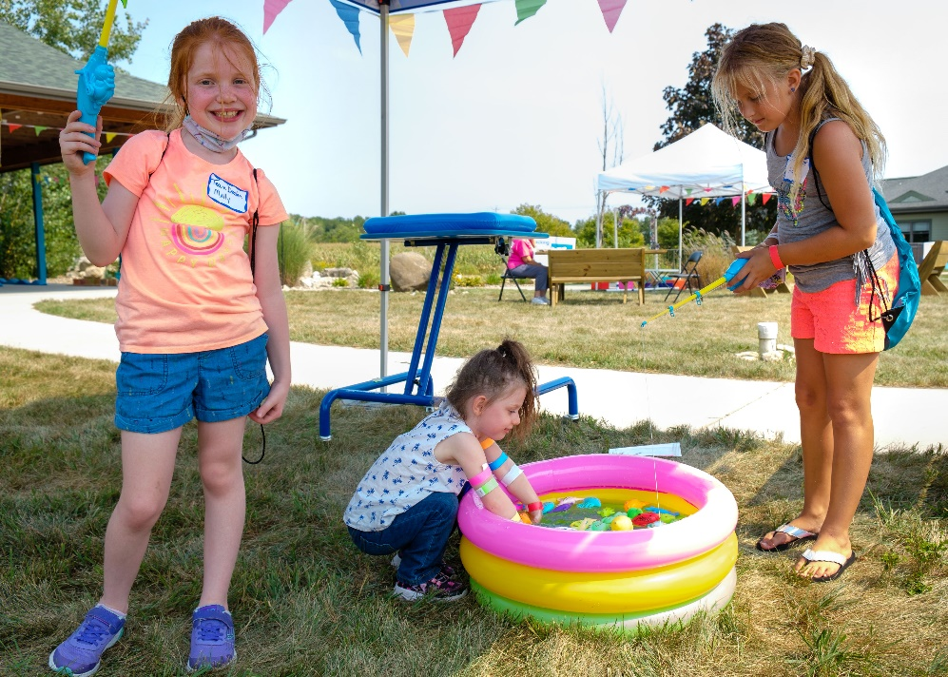
Children participate in the inaugural United Rosie Games

“In celebration of our partnership with United, and because of our mutual dedication to serve our community, A Rosie Place for Children was able to host its first ever United Rosie Games,” said Tieal Bishop, CEO/Director of Visioneering for A Rosie Place. “It was moving to see these incredible children proudly waving flags as they entered the Games Village. Families expressed so much appreciation to both organizations for this opportunity for their child! It was a wonderful day for the families caring for fragile children and the community that has surrounded them with such care.”

The non-for-profit specialty hospital serves all 92 Indiana counties and offers a haven for children who require medical intervention to sustain or enhance their lives by providing respite care for their families.
____________
About United
United Federal Credit Union has served its Members since 1949 by helping them to build a sound financial future. United consists of more than 180,000 Member/owners worldwide and manages assets in excess of $3.7 billion. Its corporate offices and main branch are in St. Joseph, Mich., with additional branches in Arkansas, Indiana, Michigan, Nevada, North Carolina, and Ohio. Federally insured by NCUA. Equal opportunity lender. Equal housing lender. For more information visit UnitedFCU.com

____________
About A Rosie Place for Children
A Rosie Place for Children is Indiana’s only licensed, not-for-profit, specialty hospital dedicated exclusively to serving the growing number of families with children who are medically fragile. A Rosie Place serves all 92 Indiana counties. Situated on five beautiful acres in South Bend, Indiana. A Rosie Place for Children is a home away from home where there are special activities for each child and relationships are built. For more information visit www.arosieplace.org

# # #

