New England Federal Credit Union

141 Harvest Lane

Williston VT 05495

(802) 879-8790

**nefcu.com**

**facebook.com/NEFCUVT**

**twitter.com/NEFCU**

**linkedin.com/company/new-england-federal-credit-union**

**NEFCU NEWS RELEASE**

**For Immediate Release**

**December 31, 2021**

**Contact: Bill Smith, Chief Marketing and Retail Officer; (802) 879-8705; smith@nefcu.com**

PHOTO CAPTION: Bill Smith, NEFCU Chief Marketing and Retail Officer (3rd from left) presented the VTANG 2021 Scholarships in December

**NEFCU PRESENTS SCHOLARSHIPS**

**TO NATIONAL GUARD ASSOCIATION of VERMONT WINNERS**

Willison, VT—On December 15th, New England Federal Credit Union (NEFCU) presented five scholarships of $1,000 each to winning applicants of the National Guard Association of Vermont (NGA-VT) annual scholarship program. On hand for NEFCU to present the checks was Bill Smith, NEFCU Chief Marketing and Retail Officer, along with Major James Lewandowski and Major Jason Beams (VNGA)

The Vermont National Guard scholarship recipients were Rachel Gates, Aiden Williams, Avery Feeley, Julie Johnston, and Wendy Carvey.

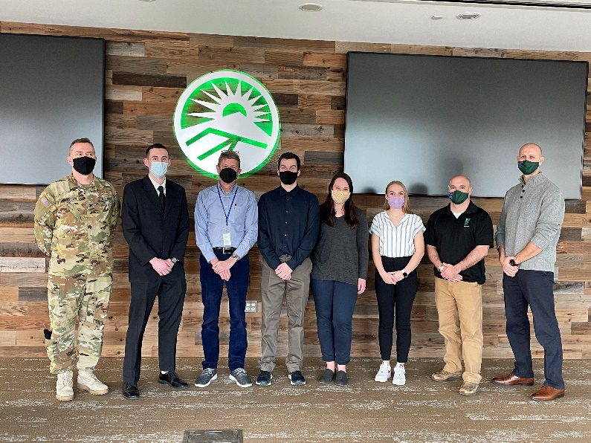

*New England Federal Credit Union (NEFCU), headquartered in Williston, Vermont is a member-owned financial institution serving communities in twelve counties of Vermont: Addison, Bennington, Caledonia, Chittenden, Franklin, Grand Isle, Lamoille, Orange, Rutland, Washington, Windham, and Windsor; and four counties in New Hampshire:* *Cheshire, Grafton, Merrimack, and Sullivan. For more information about membership requirements and benefits, visit nefcu.com.*

-30-