FOR IMMEDIATE RELEASE

For More Information Contact:
Cheryl Johnson, Cheryl Johnson PR
(913) 488-2710 • cheryl.johnson.pr@gmail.com

Where Actions Speak Louder Than Words:

Vizo Financial’s 2021 Community Efforts

Greensboro, N.C. (January 6, 2022) – Fulfilling the credit union movement’s mission of “people helping people” was at the heart of Vizo Financial’s community efforts in 2021. The Corporate harkened upon the old adage of “actions speak louder than words” to bring that philosophy to life in the communities surrounding their Columbia, S.C.; Greensboro, N.C.; Pittsburgh, Pa.; and Middletown, Pa., locations, and beyond.

Children’s Miracle Network Hospitals & Victory Junction
Vizo Financial has been a long-time supporter of both Children’s Miracle Network (CMN) Hospitals and Victory Junction, and 2021 was no exception. The Corporate showed its support for the organizations by sponsoring, hosting and/or participating in the following events:

- Walk for Children’s event for Children’s Hospital of Pittsburgh Foundation in Pittsburgh, Pa.
- Vizo Financial’s 8th Annual Hot Dog Eating Contest for CMN Hospitals at Penn State Health Children’s Hospital in Hershey, Pa.
- Pay 4 Play radiothon event for CMN Hospitals at Penn State Health Children’s Hospital in Hershey, Pa.
- CMN Hospitals Radiothon for Duke Children’s Hospital in Durham, N.C.
- Run to Victory event for Victory Junction in Randleman, N.C.

Vizo Financial sponsorship commitments and fundraising from staff contributed to over $35,000 for these two organizations in 2021.
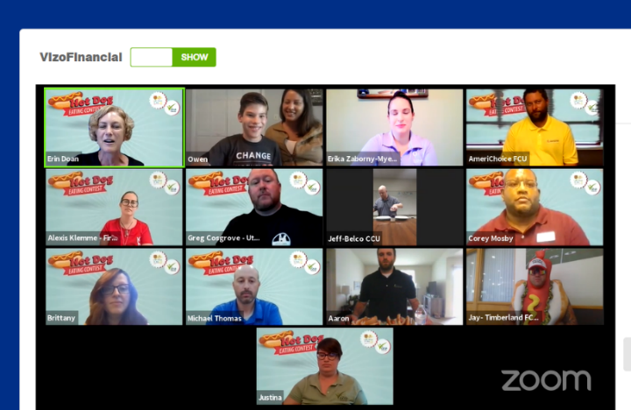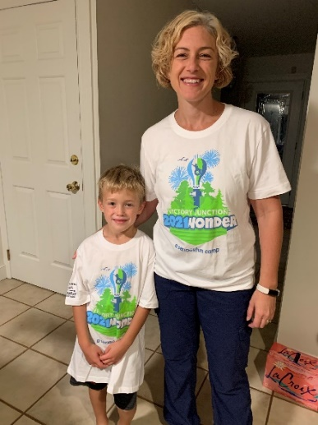

“It’s always an honor to support organizations that line up with our ‘people helping people’ philosophy,” said David Brehmer, president/CEO of Vizo Financial. “These organizations do that and so much more for those they serve, and we look forward to supporting them both now and in the future.”

Supporting 2021 Organizations
In addition to CMN Hospitals and Victory Junction, Vizo Financial chose to support the following organizations in its communities throughout 2021:

- American Cancer Society
- BackPack Beginnings
- Cure Sanfilippo Foundation
- Harvest Hope Food Bank
- Hospice of Central Pennsylvania
- Milagro House
- Pet Match Rescue PA
- ROAR Outdoors

The goal was to work together and raise funds for these well-deserving organizations, and Vizo Financial staff did just that. One such example was the auction hosted at the Middletown campus of office furniture, equipment and other goods. The sale raised $3,642, which was donated to support American Cancer Society Relay for Life, CMN Hospitals at Penn State Health Children’s Hospital, Hospice of Central PA and Milagro House.

International Credit Union Week
In honor of International Credit Union Week, Vizo Financial staff partnered with Together We Rise, a non-profit dedicated to enriching the lives of children in foster care, to create sweet cases for foster children. The sweet cases were decorated by staff and included a teddy bear, blanket, coloring book, crayons and hygiene products. They were then donated to foster children throughout the Corporate’s communities.

“International Credit Union Week is a time when we reflect on our movement and how far it has come. There’s nothing dearer to our movement than helping people in the communities we operate in,” said Erin Doan, diversity, equity and inclusion director for Vizo Financial. “We had incredible participation – 80 bags distributed in our local areas - and it was a great way to bring staff from all four campuses together over Zoom calls to decorate the bag panels and help serve foster children. We got a great response from staff following the activity.”



Additional Community Initiatives
The opportunities for giving back didn’t stop there, though. In addition to the donation efforts for CMN Hospitals, Victory Junction and the Corporate’s chosen charities for the year, staff also participated in other community initiatives. These included a Meals Around the Corporate fundraiser that raised $1,750 to benefit local food banks, sponsorships of several credit union foundation charitable events, contributions totaling $14,000 to state credit union foundations and a $10,000 donation to CUAid, which is a fund managed by the National Credit Union Foundation, for Hurricane Ida disaster relief efforts. Vizo Financial had an 88 percent staff participation rate in community-focused efforts throughout 2021.

“Putting people first is what credit unions do best,” said Brehmer. “We are proud to be a part of the credit union movement and support the organizations in our communities that are changing lives. It was a great year for community involvement opportunities, and we are humbled by the support of our employees in these efforts.”

# # #

About Vizo Financial Corporate Credit Union
Vizo Financial Corporate Credit Union’s goal is to drive credit union success through proven EXCELLENCE, unmatched EXPERTISE and engaged PARTNERSHIPS. It is a state-chartered corporate credit union that serves CUSOs, leagues, chapters and more than 1,200 credit unions in the U.S. and Canada. Vizo Financial provides money management, payments, technology, risk management and people development solutions. For more information, please visit www.vfccu.org.

