FOR IMMEDIATE RELEASE

For More Information Contact:
Cheryl Johnson, Cheryl Johnson PR
(913) 488-2710 • cheryl.johnson.pr@gmail.com

Vizo Financial Holds Joint Event to Support Victory Junction’s 16th Annual Run to Victory

Greensboro, N.C. (October 20, 2021) – Vizo Financial participated in Victory Junction’s 16th Annual Run to Victory. In conjunction with the event, the Company also held its second employee walking challenge, which began on September 20, 2021, and ended on October 17, 2021. All funds raised from this challenge were donated to the Run to Victory event.

Run to Victory is an annual fundraiser event for Victory Junction, a no-cost camp for children with disabilities in Randleman, N.C. The camp gives children opportunities to create friendships and participate in activities they never thought possible.

“Victory Junction provides so many opportunities for children with serious illnesses, and Vizo Financial is honored to once again support Victory Junction and the magic it creates for families,” said Erin Doan, Vizo Financial’s diversity, equity and inclusion director (shown here with her son).

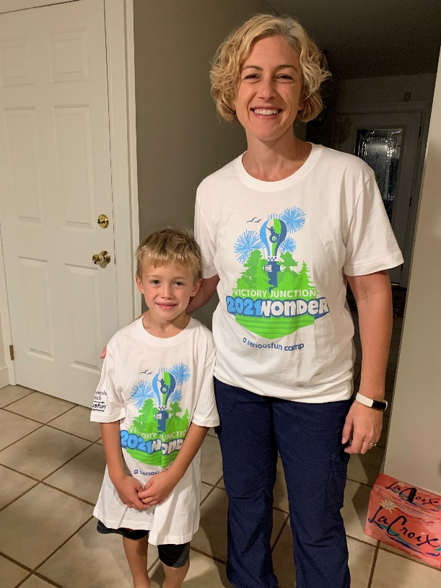

Vizo Financial’s employee walking challenge, WOW – Walkers on the Way, was a team challenge with a total of ten teams with up to ten participants per team, all of whom completed weekly challenges to earn prizes. Through this walking challenge, staff raised $1,085 to support Victory Junction’s 16th Annual Run to Victory.

“Our employees’ wellness is a top priority for us here at Vizo Financial,” said Janice Appleby, Vizo Financial’s chief human resources officer. “We strive to create opportunities that help improve our employees’ wellbeing, and we were thrilled to be able to support Victory Junction through our staff walking challenge. It was a win for our community and our employees.”

Vizo Financial would like to thank everyone who donated to support Victory Junction.

# # #
About Vizo Financial Corporate Credit Union
Vizo Financial Corporate Credit Union’s goal is to drive credit union success through proven EXCELLENCE, unmatched EXPERTISE and engaged PARTNERSHIPS. It is a state-chartered corporate credit union that serves CUSOs, leagues, chapters and more than 1,200 credit unions in the U.S. and Canada. Vizo Financial provides money management, payments, technology, risk management and people development solutions. For more information, please visit www.vfccu.org.

