FOR IMMEDIATE RELEASE

For More Information Contact:
Cheryl Johnson, Cheryl Johnson PR
(913) 488-2710 • cheryl.johnson.pr@gmail.com

Vizo Financial’s 8th Annual Hot Dog Eating Contest Raises $10,000

for Children’s Miracle Network Hospitals

Middletown, Pa. (August 10, 2021) – The competition was fierce at Vizo Financial’s eighth annual Hot Dog Eating Contest on July 21, 2021, which raised a grand total of $10,000. All money raised benefits Children’s Miracle Network (CMN) Hospitals at Penn State Health Children’s Hospital in Hershey, Pa.

The contest, held via Zoom, began with a few words from CMN Hospitals’ representative, Erika Zaborny-Myers, who works with Penn State Health Children’s Hospital. Miracle patient, Owen Zeager, and his mom, Christi Zeager, also joined the contest to share his inspirational journey and the impact that CMN Hospitals has had on his life.

Nine contestants from various credit unions competed to see who could eat the greatest number of hot dogs in five minutes. The contest was divided into a men’s competition and a women’s competition, with two women in the women’s competition and seven men in the men’s competition. The contestants included: Jeffrey Corby, AmeriChoice FCU; Greg Cosgrove, Utilities Employees CU; Jay Edmiston, Timberland FCU; Alexis Klemme, First Capital FCU; Justina Mikalik, Vizo Financial; Aaron Mowery, Belco Community CU; Corey Mosby, Blue Chip FCU; Mike Thomas, Service 1st FCU; and Jeff Thompson, Belco Community CU.

Justina Mikalik from Vizo Financial won the women’s competition, defending her title for the second year in a row, with seven and one-half hot dogs. Jeffrey Corby from AmeriChoice FCU won the men’s competition, consuming seven hot dogs.

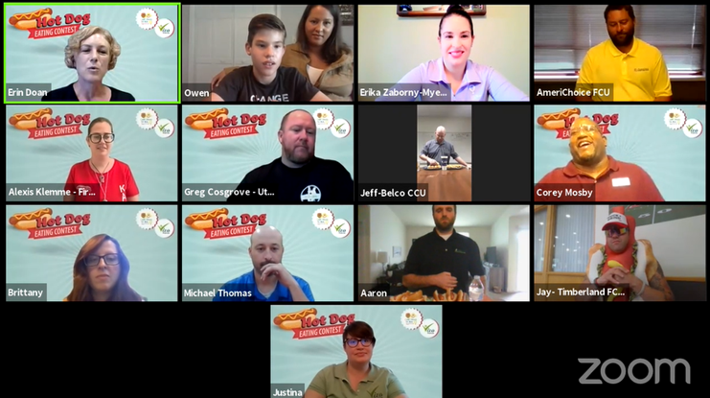
The contest was sponsored by the following 23 credit unions and credit union service organizations through the purchase of the contest’s signature All the Fixin’s or Frankfurter sponsorships:

- AmeriChoice FCU
- Belco Community CU
- Blue Chip FCU
- EP FCU
- Feather CU Services LLC
- First Capital FCU
- Greenville FCU
- Hershey FCU
- Lanco FCU
- Lebanon FCU
- Members 1st FCU
- Merck Sharp & Dohme FCU
- MY CU Services, LLC
- New Cumberland FCU
- PSECU
- Riverfront FCU
- Service 1st FCU
- Shuford FCU
- Susquehanna Valley FCU
- Timberland FCU
- Utilities Employees CU
- Vizo Financial
- Wheatland FCU

“The Hot Dog Eating Contest is an event we all look forward to here at Vizo Financial,” said Erin Doan, administration and community relations director for Vizo Financial. “This is our eighth year doing the Hot Dog Eating Contest, and the second year we’ve held it virtually. Each year, we see more success than the past year. We enjoy seeing so many credit unions come together to help our communities and support CMN Hospitals while also having a lot of fun!”

Since the contest began in 2014, it’s brought in more than $30,000 for CMN Hospitals. Vizo Financial would like to thank all the credit unions, contestants, sponsors, donors and supporters of the annual Hot Dog Eating Contest – it makes a huge difference for the kids of CMN Hospitals at Penn State Health Children’s Hospital!

A recording of the Hot Dog Eat Contest is available to view on the Vizo Financial YouTube page.

# # #
About Vizo Financial Corporate Credit Union
Vizo Financial Corporate Credit Union’s goal is to drive credit union success through proven EXCELLENCE, unmatched EXPERTISE and engaged PARTNERSHIPS. It is a state-chartered corporate credit union that serves CUSOs, leagues, chapters and more than 1,200 credit unions in the U.S. and Canada. Vizo Financial provides money management, payments, technology, risk management and people development solutions. For more information, please visit www.vfccu.org.

