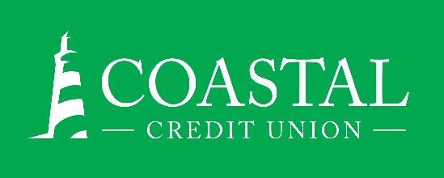
NEWS RELEASE
Contact: Joe Mecca
VP, Communication / Spokesperson
919-420-8044 /jmecca@coastal24.com
FINAL – For Immediate Release

Coastal Wealth Management Wins Three Production Awards
RALEIGH, N.C. (February 24, 2022) – Coastal Wealth Management, available through CFS*, is the recipient of three Pacesetter Awards, presented by CUSO Financial Services, L.P. This is the eighth consecutive year that Coastal Wealth Management has earned recognition, collecting 17 awards during that time period.

CFS* financial advisors Jonah Kaufman and Catherine Bryant earned a gold level Pacesetter awards for meeting 2021 production goals and providing outstanding client service. Additionally, advisor David Burk was recognized with a silver level Pacesetter award.

“The success of our Program is a team effort. Our program’s primary goal is to help our members review all aspects of their financial journey and identify doable steps to reaching a secure financial future through our Financial Planning Process. An individualized Financial Plan is the compass our members can follow with the guidance of our CFS* financial advisors to provide them direction towards their goals and dreams.” said MaryAnne Gangoy, VP, Wealth Management.

“In addition, we work very closely with our Coastal Partners to identify ways to save our members money through our referral process. Member expectations have changed, so we need to understand our memberships’ goals. Our Program continues to adapt and stay innovative in our offerings and our team strives to provide a high level of member service.”

About Coastal
Coastal Credit Union is a not-for-profit, member-owned, financial cooperative, offering a full range of financial products and services. Coastal was chartered on August 31, 1967 with the mission of fostering the credit union philosophy of “people helping people.” Today, with $4.61 billion in assets, Coastal serves 302,000 members from 1,800 business partners and is among the leading financial institutions in North Carolina. Coawstal operates 23 branches in central North Carolina and serves members in all 50 states through a network of 5,000 shared branches, 30,000 surcharge-free ATMs, mobile banking featuring mobile check deposit, and a robust offering of online services at www.COASTAL24.com. For more Coastal news, visit our online newsroom.

*Non-deposit investment products and services are offered through CUSO Financial Services, L.P. (“CFS”), a registered broker-dealer (Member FINRA / SIPC) and SEC Registered Investment Advisor. Products offered through CFS: are not NCUA/NCUSIF or otherwise federally insured, are not guarantees or obligations of the credit union, and may involve investment risk including possible loss of principal. Investment Representatives are registered through CFS. Coastal Credit Union has contracted with CFS to make non-deposit investment products and services available to credit union members.
###

