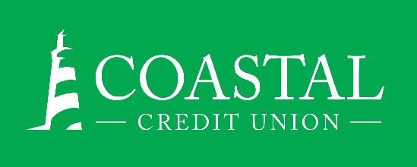
NEWS RELEASE
Contact: Joe Mecca
VP, Communication / Spokesperson
919-420-8044 /jmecca@coastal24.com
FINAL – For Immediate Release

Coastal Wealth Management Wins Three Production Awards
RALEIGH, N.C. (May 18, 2021) – Coastal Wealth Management, available through CFS*, is the recipient of three Pacesetter Awards, presented by CUSO Financial Services, L.P. This is the seventh consecutive year that Coastal Wealth Management has earned recognition.

CFS* financial advisor Jonah Kaufman earned a gold level Pacesetter award for meeting production goals and providing outstanding client service. It is his sixth overall award and Coastal’s first gold. He was also profiled in the March/April issue of The Edge, CFS’ bimonthly publication. Additionally, advisors Catherine Bryant and Martin Gabel were recognized with bronze level Pacesetter Awards.

“The success of our program is a team effort,” said MaryAnne Gangoy, VP, Wealth Management “In addition to the referrals generated by other departments, being able to pivot to digital member engagement was critical to our 2020 success. Our team and Coastal’s marketing team worked hard together to launch streaming web events in the midst of COVID. It is one of the main factors that helped our advisors connect with our members to understand their Financial Planning goals while the branch lobbies were closed.”

About Coastal:
Coastal Credit Union is a not-for-profit, member-owned, financial cooperative, offering a full range of financial products and services. Coastal was chartered on August 31, 1967 with the mission of fostering the credit union philosophy of “people helping people.” Today, with $4.2 billion in assets, Coastal serves 282,000 members from 1,800 business partners and is among the leading financial institutions in North Carolina. Coastal operates 23 branches in central North Carolina and serves members in all 50 states through a network of 5,000 shared branches, 30,000 surcharge-free ATMs, mobile banking featuring mobile check deposit, and a robust offering of online services at www.COASTAL24.com. For more Coastal news, visit our online newsroom.

*Non-deposit investment products and services are offered through CUSO Financial Services, L.P. (“CFS”), a registered broker-dealer (Member FINRA / SIPC) and SEC Registered Investment Advisor. Products offered through CFS: are not NCUA/NCUSIF or otherwise federally insured, are not guarantees or obligations of the credit union, and may involve investment risk including possible loss of principal. Investment Representatives are registered through CFS. Coastal Credit Union has contracted with CFS to make non-deposit investment products and services available to credit union members.
###

