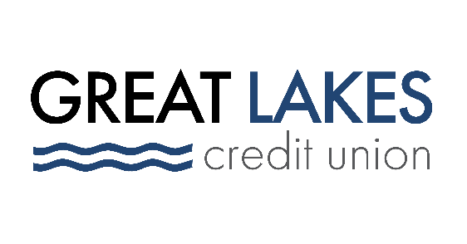

www.glcu.org
FOR IMMEDIATE RELEASE | Contact: Media Department  media@glcu.org  (847) 578-7324
Great Lakes Credit Union Sponsors “Who Am I”, Inaugural Youth Summit in Bolingbrook, IL

BANNOCKBURN, IL (Feb. 3, 2022) – Great Lakes Credit Union (GLCU) is sponsoring the inaugural “Who Am I” event organized by the NFL Players Association (NFLPA) Former Players - Chicago Chapter, The Village of Bolingbrook and other community organizations. The summit brings together youth from ages 12 to 17 to discuss pertinent issues and provide the necessary tools to navigate their future.

The event will take place on Saturday, February 5, from 1:00 p.m. to 4:00 p.m. CT at the Bolingbrook Recreational Aquatic Center, 200 Lindsey Ln.

“GLCU is proud to sponsor an event that will leave behind a positive impact in the community and, most importantly, with our youth,” said Abraham Santiago, Senior Manager of Community and Financial Education programs. “Thinking of the future can seem so far-fetched when you are young. One of the best ways to equip our younger generations is through events like these that create a space to have conversations not regularly held.”

The event features career professionals and former NFL Athletes covering topics such as confidence, leadership, mental health, social media, and much more. Former NFL athletes serving as panelists include, Shafer Suggs from the New York Giants, Brent Novoselsky from the Chicago Bears, Gemará Williams from the New England Patriots, and Reggie Smith from the Denver Broncos.

“So many parents have a ‘not my child’ attitude when it comes to talking about mental health and other issues. I truly believe this event is for every single child, and we could not be prouder that it's taking place in Bolingbrook. Empowering today’s youth is key to their success, and each sponsor has a part in making a difference,” said Mayor Mary Alexander-Basta of The Village of Bolingbrook.

More than 50 teenagers are registered to participate in an afternoon of engaging activities at the Bolingbrook Recreation Aquatic Center.

Great Lakes Credit Union is grateful for the opportunity to support the inaugural “Who Am I” event. GLCU is committed to financial empowerment for everyone and giving back to its communities is one of the credit union’s core values.

About Great Lakes Credit Union
Founded in 1938 and headquartered in Northern Illinois, GLCU is committed to financial empowerment for you. As a not-for-profit financial cooperative with over $1 billion in assets, GLCU is proud to serve more than 80,000 members in the Chicagoland and surrounding areas. Learn more about GLCU’s accounts, educational initiatives and community development programs at glcu.org

