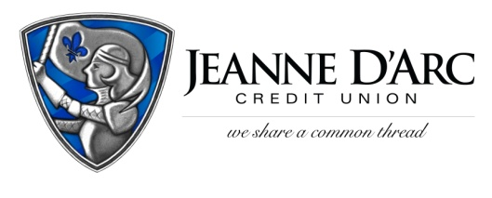

FOR IMMEDIATE RELEASE CONTACT: Robin Lorenzen
WITH PHOTO 978-323-3226
November 18, 2021

Jeanne D’Arc Credit Union Gives Back on World Kindness Day
LOWELL, MA- To celebrate World Kindness Day (November 13, 2021), Jeanne D’Arc Credit Union surprised customers on November 15 at the Fletcher Street Market Basket in Lowell, with Market Basket Gift Cards as part of the Credit Union’s Small Acts That Give Back initiative.
For the past four years, Jeanne D’Arc Credit Union’s President and CEO, Mark Cochran, and team members have surprised Market Basket shoppers around the holidays by handing out 100, $15 Market Basket Gift Cards.
Small Acts That Give Back was introduced in 2018 and is the Credit Union’s version of Random Acts of Kindness. The mission is to spread joy and compassion to the community, and in celebration of World Kindness Day, a day focused on the importance of being kind to one another, this becomes even more of a focus.
“Small Acts That Give Back is a compilation of small gestures that allow us to spread a little kindness throughout our communities,” said Mark S. Cochran, President and Chief Executive Officer at Jeanne D’Arc Credit Union. “We hope through these small acts we can not only help those in need but inspire others to pay their good fortune forward.”
###
About Jeanne D’Arc Credit Union:
Jeanne D’Arc Credit Union was established in 1912 and is a full-service, community-based financial cooperative. Locally owned by 93,000 members with $1.7 billion in assets, Jeanne D’Arc operates eight full-service branches in Lowell, Dracut (2), Tyngsboro, Chelmsford, Methuen and Westford, Massachusetts and Nashua, New Hampshire; high-school branches at Lowell High, Dracut High, and Nashua High School South; a loan center in Lowell; and a mortgage center in Chelmsford.

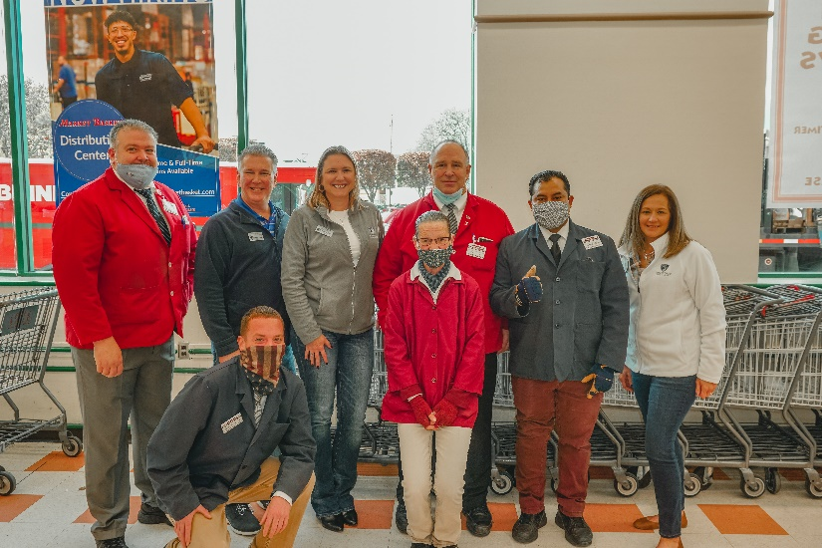
Jeanne D’Arc Credit Union visits Fletcher Street Market Basket in Lowell on World Kindness Day to give Market Basket gift cards as part of the Small Acts that Give Back initiative. Jeanne D’Arc Team Members in photo (back row, second from left) Mark S. Cochran, President and Chief Executive Officer of Jeanne D’Arc Credit Union; Alison Hughes, AVP – Community Engagement Officer, and (right) Robin Lorenzen, Senior Vice President and Chief Marketing Officer, join Mike Morowski, Store Manager, and the Fletcher Street Market Basket team.

