Texas Trust Credit Union Sees Superior Growth in 2020
Despite Pandemic’s Challenges, Credit Union Grew Total Assets 16.3%
Arlington, Texas – March 21, 2021 – Texas Trust Credit Union keenly focused on helping members through the global pandemic last year, resulting in superior growth in 2020. The $1.6 billion credit union’s rapid crisis response enabled it to help members remain financially sound during the crisis. The credit union also continued to give the communities in which it does business, maintaining the credit union philosophy of “people helping people.”
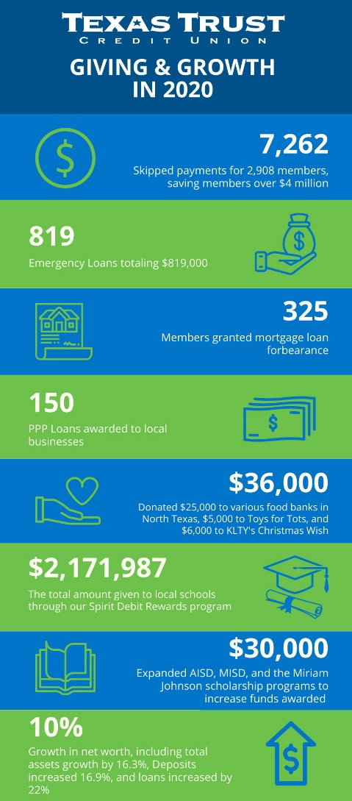
Texas Trust pivoted their strategy to focus on pandemic response, helping members in need, and as a result, ended 2020 with 10 percent growth in net worth. Total assets grew 16.3 percent. Deposits increased 16.9 percent and loans 22 percent, year over year, marking one of the best years for the credit union.

Texas Trust funded hundreds of emergency personal loans and approved more than 7,500 members to skip loan payments up to three months without any penalties or fees. The credit union also worked with small businesses to help them obtain Paycheck Protection Program loans from the federal government. Also, to help members manage the financial upheaval brought on by the pandemic, they were allowed to withdraw money from their CDs and holiday club accounts with no penalty. In addition, transaction requirements on a popular checking account were waived.

Texas Trust helped nearly 300 members refinance auto loans at lower rates, saving them a minimum of $50/month. These members were given the ability to also extend payment terms and defer their first payment up to 120 days.

Texas Trust also offered relief to 325 members with mortgage loans, granting forbearances and loan modifications that affected more than $45 million in loans.

Texas Trust responded to the community need of local food banks that were seeing unprecedented demand. The credit union donated a total of $25,000 to three food banks, which allowed them to provide more than 131,000 meals to those in need.

The credit union also expanded its scholarship program last year, giving more than $30,000 in scholarships. Texas Trust also gave merrily during Christmas time to Toys for Tots and granted $6,000 in Christmas wishes to two deserving families through the KLTY Christmas Wish campaign.

“Last year will be remembered for years to come by everyone,” said Jim Minge, CEO of Texas Trust Credit Union. “Our employees worked through extreme challenges – both professionally and personally – and I am proud of what they accomplished. We are a stronger organization because of their determination and hard work.”

Minge added, “Our members also struggled with numerous financial obstacles brought on by the pandemic. We are committed to continuing to provide financial services and tools to help them build brighter financial futures.”

A copy of Texas Trust’s 2020 Annual Report can be downloaded here. And the infographic is available here.

About Texas Trust Credit Union
Texas Trust Credit Union has been helping build brighter financial futures since its modest beginning in 1936. Today, the full-service credit union serves more than 120,000 members. With assets of more than $1.6 billion, Texas Trust is the 5th largest credit union in North Texas and the 16th largest in Texas. With a focus on the community, Texas Trust is creating a legacy of giving through generous financial donations that support local school programs and activities, non-profit organizations, and student scholarships; and by providing volunteer resources through its Community Unity team, which supports scores of charitable events each year. For more information, visit TexasTrustCU.org or follow us on Facebook at facebook.com/texastrustcu or Twitter at @texastrustcu.

###

