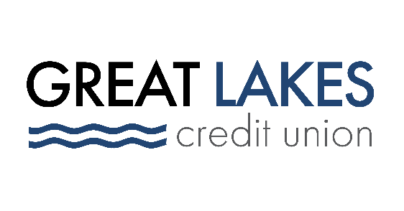

FOR IMMEDIATE RELEASE

Great Lakes Credit Union Announces Partnership with Alliance for the Great Lakes

Bannockburn, IL – Nov. 22, 2021 – Great Lakes Credit Union announced today it has established a partnership with the Alliance for the Great Lakes, a nonpartisan nonprofit working across the region to protect a vital resource: the fresh, clean and natural waters of the Great Lakes. GLCU will serve as Lead Financial Corporation Partner for the group, supporting education and advocacy programs.
“We are thrilled with this new partnership and how it will benefit the Alliance and the community as a whole,” said President & CEO of Great Lakes Credit Union Steve Bugg. “This relationship brings forth not only boosted awareness of important environmental matters, but we also align our core missions: to empower, engage and better the communities in which we serve.”
The Alliance for the Great Lakes connects and empowers people to advocate, give back and take action to protect the lakes through a three-pronged approach: Advocacy and leadership, developing actionable solutions that protect the lakes through partnerships with communities and decision makers; education & action, empowering people to protect the lakes by providing action-oriented information and programs; and lastly research & analysis, informing community leaders and working in tandem to create and guide legislative policy to protect the Great Lakes.
“We’re honored to partner with GLCU,” said Alliance for the Great Lakes President & CEO Joel Brammeier. “We share a commitment to supporting Great Lakes communities and providing action-oriented solutions for individuals to address their communities most pressing issues.”
GLCU and the Alliance will partner on a variety of initiatives including public education events, cleanup of area beaches through the Alliance’s Adopt-a-Beach program, promotional product giveaways, and many other public awareness events that promote the conservation of the Great Lakes and surrounding region.

About Great Lakes Credit Union
Founded in 1938 and headquartered in Northern Illinois, GLCU is committed to financial empowerment for you. As a not-for-profit financial cooperative with over $1 billion in assets, GLCU is proud to serve more than 80,000 members in the Chicagoland and surrounding areas. Learn more about GLCU’s accounts, educational initiatives and community development programs at glcu.org

About the Alliance for the Great Lakes
The Alliance for the Great Lakes is a nonpartisan nonprofit working across the region to protect our most precious resource: the fresh, clean and natural waters of the Great Lakes. Alliance staff are headquartered in Chicago, with additional offices in Michigan, Ohio, New York, and Wisconsin. To learn more and to get involved, visit www.greatlakes.org

Media Contacts:
media@glcu.org
(847) 578-7327

Jennifer Caddick
jcaddick@greatlakes.org

